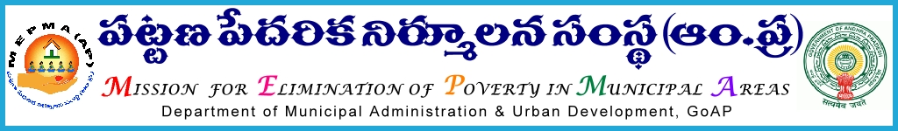

From  Smt Anita Ramachandran, I.A.S.,  Mission Director,  MEPMA,  HYDERABAD - 500 004 | To  The Project Directors  MEPMA

Lr.Roc.No. / MEPMA/2012/C(H) /C2 Dated : 12.08.2013
Sir,

Sub:- MEPMA-CH- Adolescent issues- three days training programme on “YUVA Awareness on adolescent issues for Urban Community Health Workers “From 22.8.2013 to 24.8.2013 at MCHRD – nominate the Tot Health –CRPs 2 per - Certain instruction – Reg.

Ref: - 1. Lr.T6 /CUDS/657/2013 Dated 26.07.2013 circular from Spl CS to Govt to MD MEPMA

2. MEPMA Action Plan2013-2014

***
As Part of implementation of Community Health –Adolescent Issues it is decided to promote a platform for awareness on adolescent issues of biopsycho social aspects of adolescent life skills, High risk behavior and its consequences, academic problems and career guidance awareness, councilling skills and case history taking and report writing etc.

In this subject The Centre for Urban Development Studies, Dr.MCR HRD Institute is organizing a Three day training programme on “YUVA Awareness on adolescent Issues for Urban Community Health Workers.” Sponsored by the Department of Personnel & Training, Govt Of India, from 22.08.2013 to 24.08.2013 at its premises located on Road No 25, Jubilee Hills Hyderabad 500169.

In this regard it has been decided to nominate the Tot H-CRPs those attended at VET Homes @ 2 members from each district for the above said training Programme at MCHRDI Rd No.25, Jubilee Hills, Hyderabad.

Therefore, the Project Directors, MEPMA are requested to send the participants list from District wise along with the phone Nos. and Email ID if any before 17th August, 2013. Nomination may be send to Dr. Deepa Nair, Dy. Director & Assoc. Professor, CUDS, Mobile N0.9391049802 & email: Valathai@gmail.com under intimation to Dr. Sujatha Sr. Specialist Community Health& Disability(FAC) MEPMA Ph No. 9701385131 email: sujatha@apmepma.gov.in.

Further, it is informed that the travel expenditure shall be borne as per the norms prescribed by MEPMA from out of community structure / UCDN funds of SJSRY.

Sd/-Anita Ramachandran,

Mission Director
Copy to the Director General, MCHRD Hyderabad

