From To
Smt Anita Ramachandran,I.A.S., All Project Directors in the State
Mission Director,
MEPMA
Hyderabad.

Sir / Madam,
Lr Roc. No.3/M&E/Online Updation/2013, Dated 28.10.2013
Sub: MEPMA – Guidelines for updating bank linkage in http://ikp.serp.ap.gov.in/mepmabl portal – Reg.
***
As you aware that the entry screen for loan disbursement / Bank Linkage has been provided in http://ikp.serp.ap.gov.in/mepmabl portal.
The following are the guidelines to update bank linkage in the above portal. There are two types of loans.
- Term Loan
- CCL
The following steps need to be followed to update the bank linkage.
Term loan:
To update the term loan, the old loan status need to be closed, then you can enter the new loan. To update this the following steps can be followed
  - Update SHG SB a/c
  - Update Loan a/c
  - Update loan details
  - In Loan Disbursement screen
    - Update the loan type as Term Loan
    - Update the loan status as closed
    - Select the term loan radio button and enter the loan details
Note: If the SHG and Loan Details are entered in http://ikp.serp.ap.gov.in/mepmabl portal. The above steps from a to c are not required.
CCL:
If a CCL is renewed, the loan status needs to be Running, then the following steps can be followed
- Update SHG SB a/c
- Update Loan a/c
- Update loan details
- In Loan Disbursement screen
- Update the loan type as CCL
- Update the loan status as Running.
- Then select CCL loan radio button. In CCL Loan Details window, Renewal link will be enabled. By clicking on that link, you can enter the CCL renewal details.

- If any SHG has changed from one Bank to another Bank, to change the account in online portal the following steps can be followed.

  - If the SHG SB account not updated in TPRO login, go to SHG SB account updation screen and update Bank, Branch and SB a/c number.
  - If the SHG SB a/c updated in TPRO login, you can update the details in PD login.

Yours faithfully,S
Sd/- Anita Ramachandran
MISSION DIRECTOR
Enclosure: Detailed screenshots
Guidelines for updating the Bank Linkage in http://ikp.serp.ap.gov.in/mepmabl portal

Step 1:
Update SHG SB account number.

Step 2:

Update the loan A/c No. As, shown below.
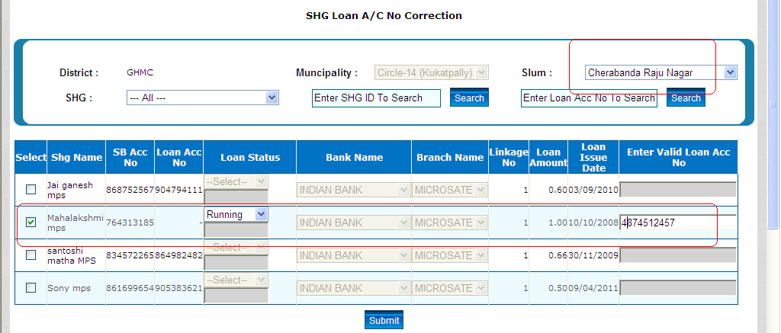

Step 3: Then update the loan details for it

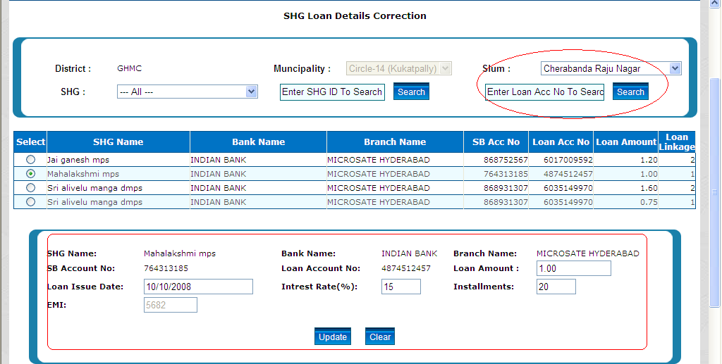
Step 4:
After updating loan details, In Loan Disbursement screen, the option to update the loan type is enabled, as shown in the below image

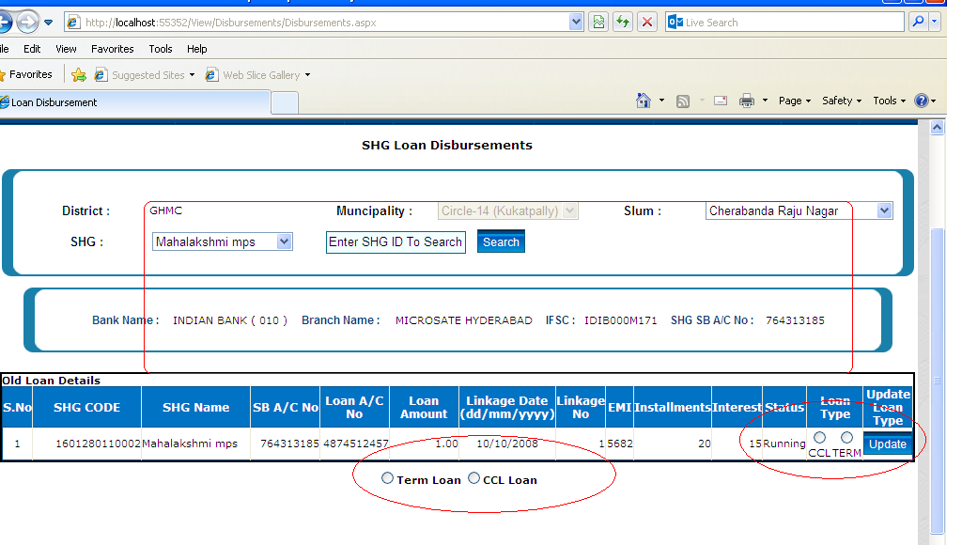

Step 5:
After updating the loan type the details will be binded to the corresponding loan type grid, as shown below
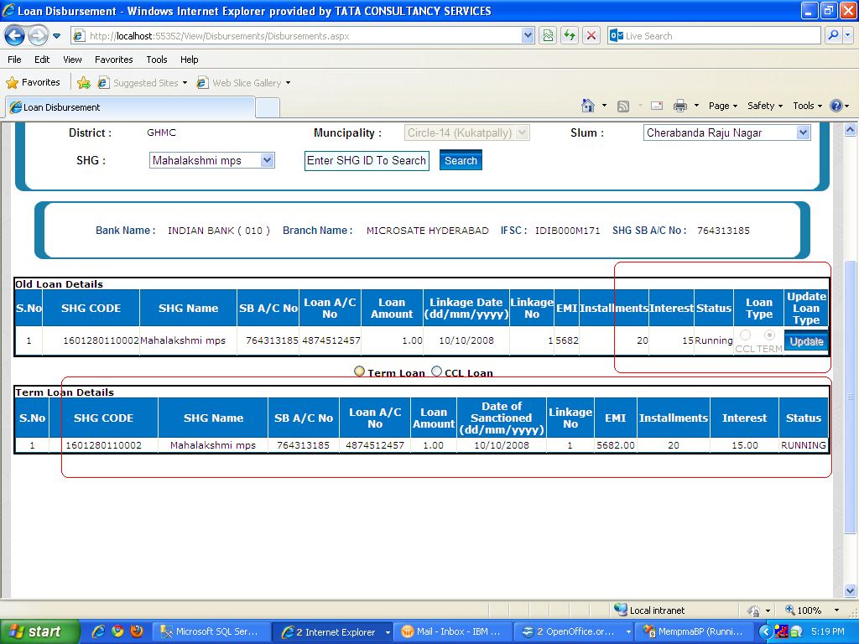
Note: For entering new Term Loan: Previous Term Loan status shall be Closed. And for entering CCl renewal, CCL status shall be Running.

Step6: To Update the loan status in Loan Disbursement screen.

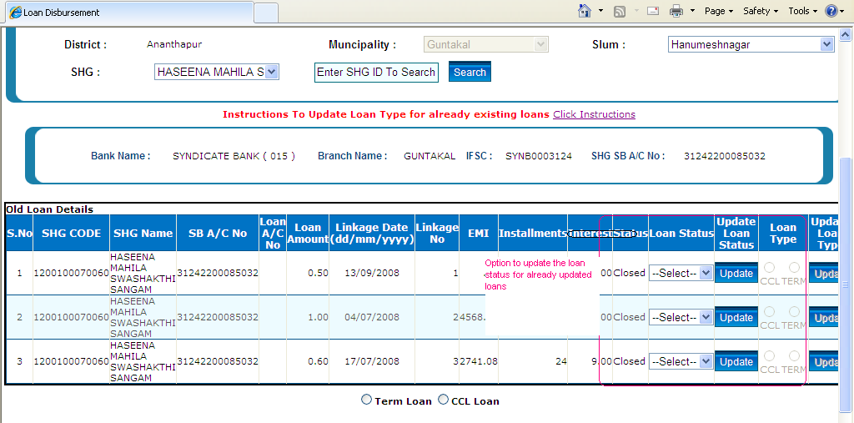

Select the loan status that you want to update.
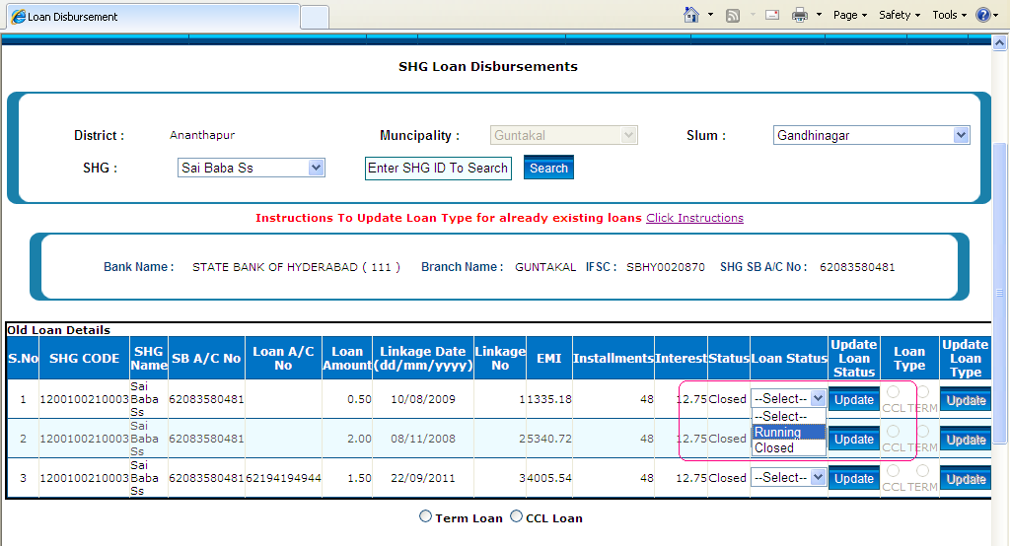

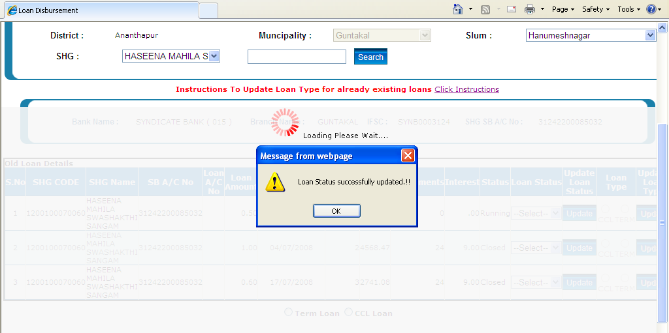

After updation the status will be change and the change will be reflected in 'Status' column.

Step 7:
Now You can update the Term/CCL loan

