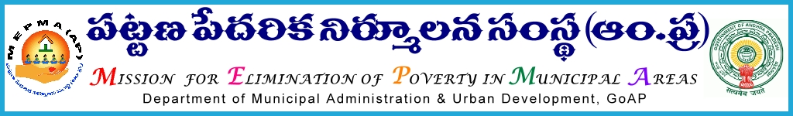

From To
Smt Anita Ramachandran,I.A.S., Project Directors ,
Mission Director, MEPMA All districts, MEPMA.
Hyderabad.

Lr.Roc.No. 4554/ D1 –dated: 4.12.2013
Sir ,
Sub:MEPMA – payment of support fund to TLF towards remuneration to CLRPs, DEOs,TLF RPs & PWD volunteers – certain instructions – issued – regd.
Ref: 1.This office circular Roc No 296/ UCDN dated 7.7. 2011, 14.6.2013
2.This office detailed guidelines communicated vide Roc No 1216/D1 dated 22.2.2012.
3.Guidelines for positioning the services of PWD volunteers through TLFs.

************

It is to inform that vide references cited above, detailed guidelines were already communicated to all PDs regarding support fund /Managerial support to be released to TLFs towards payment of remuneration to CLRPs, DEOs, PWD volunteer and TLF RPs.
  - In this connection, all PDs are instructed to release funds towards remuneratin to CLRPs,TLF RPs, DEOs,PWD volunteers from Dec’2013 to Mar’2014 from available funds under any subhead of UCDN component. (Utilisation certificate for earlier released funds may be obtained latter)
  - All the functionaries to be invariably paid remuneration payable on Dec’2013 on 1st of Jan’2014.
  - Any lapses on the above matter would be viewed seriously.
Sd/Smt Anita Ramachandran,I.A.S.,
Mission Director,
MEPMA

