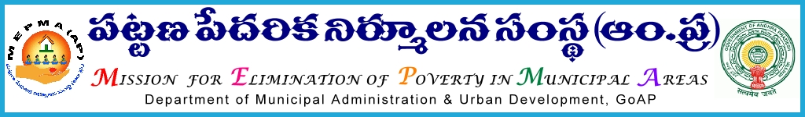

From To
Smt Anita Ramachandran,I.A.S., Project Directors ,
Mission Director, MEPMA All districts, MEPMA.
Hyderabad.

Lr.Roc.No. 4554/ D1 –dated: 4.12.2013
Sir ,
Sub: MEPMA – payment of support fund to TLF towards remuneration to CLRPs, DEOs,TLF RPs & PWD volunteers – certain instructions – issued – regd.
Ref: 1.This office circular Roc No 296/ UCDN dated 7.7. 2011, 14.6.2013
2.This office detailed guidelines communicated vide Roc No 1216/D1 dated 22.2.2012.
3.Guidelines for positioning the services of PWD volunteers through TLFs.

************

It is to inform that vide references cited above, detailed guidelines were already communicated to all PDs regarding support fund /Managerial support to be released to TLFs towards payment of remuneration to CLRPs, DEOs, PWD volunteer and TLF RPs.

PDs are once again instructed to furnish the proposals for requirement of funds towards remuneration to CLRPs, TLF RPs , DEOs and PWD volunteers - for the year 2014-2015 ( April’2014 to Mar’2015) by obtaining resolution from TLFs before 31st of Dec’2013 , to MEPMA office, without fail.

Sd/Smt Anita Ramachandran,I.A.S.,
Mission Director,
MEPMA

