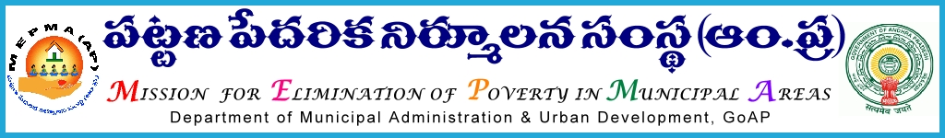
From To
The Mission Director, All the Project Directors of MEPMA,
MEPMA, and
Hyderabad. POs of GHMC, GVMC & VMC.

Lr. Roc. No. 15183/09/D2/VLR, Date: 30-12-2013.
Sub: VLR – Disbursement of VLR directly to the SHG Loan accounts from January 2014 – Regarding.
Ref: 1) This office Lr. Roc. No. 15183/09/D2/VLR, dated: 04-12-2013.
2) This office Lr. Roc. No. 15183/09/D2/VLR, dated: 05-12-2013.
3) This office Lr. Roc. No. 15183/09/D2/VLR, dated: 18-12-2013
****
With reference to the above, it is to inform that the TCS has processed the outstanding Term Loan accounts and CCL accounts of SHGs as at the end of November 2013 and arrived at the Principal Part & Interest Part and kept the same under reports separately as “Fixed Principal Interest reports – for TERM loans & CCL loans”.
Please note that in case of Term Loans, the Principal and Interest amount will be the same till the existing Term Loan accounts is closed. In case of CCL accounts the Principal and VLR amount varies every month depending on the outstanding amount. The SHG has to repay 3% of the outstanding principal amount every month to become eligible for VLR.
TCS will generate eligible VLR amount SHG wise for the month of January 2014 based on the Repayments in December 2013. From January 2014 onwards the Part B amount i.e., Interest Portion will directly be credited to SHG Loan accounts by way of online transfer from MEPMA H.O PD account.
It is decided to inform and educate all the SHGs through SLFs & TLFs OBs, and RPs about the repayment of only Principal portion by SHGs from the month of January 2014.
All the PDs of MEPMA and POs of GHMC, GVMC & VMC are advised to fulfill the following steps for implementation of direct transfer of VLR amount to the SHG loan accounts from January 2014.
- Ensure to enter all outstanding loan accounts in Loan Disbursement screen, and update November 2013 outstanding balances for Non-data sharing Bank Loan accounts immediately.
- Download the Principal portion now kept by TCS for Term Loan accounts and send the hard copies to ULBs with an advice to communicate to all the SHGs to repay the Principal amount only in January 2014 before the due date.
- The eligible VLR amount for the month of January 2014 will be worked out by TCS based on the repayments in the month of December 2013 and generate SHG wise eligible VLR amount before 18th January 2014 and the VLR amount will be transferred to SHG loan accounts directly by MEPMA before the end of January 2014. The same process will be repeated every month.
- The PD has to prepare the proceedings for the total VLR amount eligible for the month of January 2014 and submit with his/ her recommendations to H.O. by 20th January 2014 for crediting to SHG loan accounts directly by way of online transfer.
Please act immediately as per the above instructions.

Sd/-
MISSION DIRECTOR

