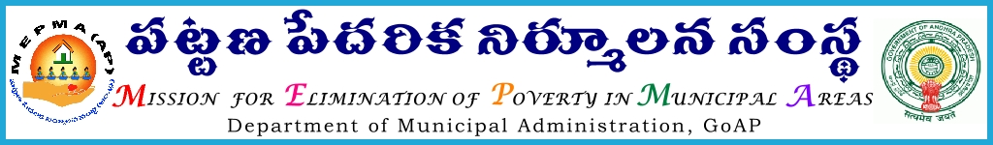
From To
Smt. Anita Ramachandran, I.A.S., The Project Directors,
Mission Director, DPMUs in the State
MEPMA, A.P., The P.D. (UCD) GVMC &VMC
Hyderabad.

Lr. Roc. No. 75/12/ C, Date: 10.01.2014

Sir/Madam,
Sub: - MEPMA–Implementation of RYK Programme–Information on telecast/broadcast of “Avadhulleni Avakasalu” live phone– in programme on every Saturday/Tuesday i.e., from 7:30 PM to 8:00 PM/ 7:15 AM to 7:45 AM under RYK programme- Regarding.

Ref: - Circular No 2/REEAMP/DD-AIR/ 2014 dated: 04-01-2014 from MD REEMAP, Hyderabad
<><><>

I invite your attention to the reference cited wherein it is informed that, during the meeting held with Hon’ble Chairman, REEMAP it was discussed that greater visibility to the RYK programme can be brought out by rolling out media campaign which will enable to achieve the goals of RYK and it is proposed to have a mass outreach especially to the rural youth by having a live phone-in programme with Doordarshan and All India Radio.

The telecasting and broadcasting programmes scheduled are as follows:

- Telecasting in Doordarshan Saptagiri channel “Avadhulleni Avakasalu” live phone in programme on every Saturday starting from 04-01-2014 to 29-03-2014 from 7:30 PM to 8:00 PM.

- Broadcasting in All India Radio “Avadhulleni Avakasalu” live Phone in programme on every Tuesday starting from 07-01-2014 to 25-03-2014 from 7:15 AM to 7:45 AM.

Therefore, you are directed to inform the schedule of Doordarshan and All India Radio programmes (as mentioned above) to the field level staff and ensure to watch the programmes and generate interest among the youth about RYK Programme which will create awareness about unlimited job opportunities in the market for them.

Callers No 040-27031431/32/33

Yours faithfully,
Sd/-Anita Ramachandran
MISSION DIRECTOR
Copy to:
The MD REEMAP, Hyderabad for information

