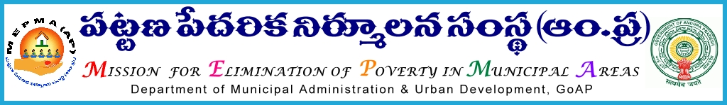
From To
The Mission Director, All the Project Directors of MEPMA
MEPMA, and
Hyderabad. PDs of GHMC, GVMC & VMC.
Lr. Roc. No. 40/BL/2010-11, Date: 28-02-2014.
Sub: Review meeting of District Mission Coordinators (BL) on 01-03-2014 – Postponed and combined with State Level Bankers Meeting on 07-03-2014 at Haritha Plaza, Banquet Hall, Paryatak Bhavan, Begumpet, Hyderabad– Regarding.
@@@@
Further to this office letter dated: 22-02-2014, it is decided to hold a One day State Level Bankers Workshop along with the Controlling Officers of all major Banks, TLF OBs in the presence of the Convener SLBC.
The meeting is scheduled to commence @ 10.30 am on 07-03-2014 at Haritha Plaza, Banquet Hall, Paryatak Bhavan, Begumpet, Hyderabad. During the interaction with the Senior Level Controlling Officers of major Banks, all the TLF President / Secretary or any other EC member from each District are requested to put forth their specific problems faced by them at the field level with any specific Bank / Branch.
The PDs are instructed to depute two TLF OB members from each District of which one TLF OB should preferably be from the District Head Quarters. They should ensure that the two TLF members should be able to put forth boldly the problem encountered by all the Urban SHGs in the District, pertaining to any Bank and should not be restricted to their own TLFs / SLFs/SHGs. They can also highlight the good work done by the Banks in the District. The PDs, TMCs (BL) shall conduct meetings in advance and prepare specific Bank wise / Branch wise issues and present a consolidated view of issues of the District and a copy of the same is to be sent in advance, however not letter than 05-03-2014 to MEPMA H.O.
The interaction with TLF OBs, SLBC Convener and the participating State Level Bankers will be upto 1.00 pm followed by Lunch, after which the TLF OB members can return back to their respective places. In the post Lunch session i.e., 2.00 to 5.00 pm the review with the DMCs (BL) will continue.
Sd/-
MISSION DIRECTOR

