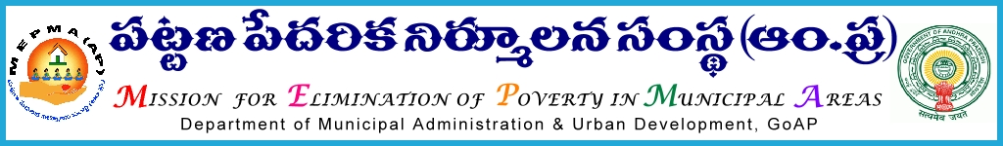

From  Smt Anita Ramachandran, I.A.S.,  Mission Director,  MEPMA,  HYDERABAD - 500 004 | To  The Project Directors  MEPMA  MEPMA  .  .
Lr.Roc No 431 /MEPMA/Disability /D1 Dated: 9 .05.2014

Sub : MEPMA-Disability interventions – Capacity Building trainings to the 165 PWD
Volunteers on Book Keeping rescheduled to 19th May, 2014 to 30th May 2014-Depute the PWD Volunteers -RCUES –Reg.,

Ref :- 1. This office circular 431/DIS/D1/UCDN Dated 04.05.2013
2. This Office circular Lr.Roc.No No 431 /MEPMA/Disability /D1 Date: 10.03.2014

***
I invite the attention of the Project Directors, MEPMA in the State to the reference 2nd cited , the proposed trainings is rescheduled to 19th May 2014 up to 30th May 2014 on Book Keeping to PWD Volunteers in all ULBs at RCUES ,Hyderabad.

Hence all the Project Directors, MEPMA are instructed to depute the PWD Volunteers to RCUES, Hyderabad as per the given schedule and ensure that they shall report at the venue before 9.30 am on scheduled date of starting

- S.No | - Name of the Districts | - Date of  - training | - No. of  - Participants | - Address  - Contact, Number  - Training institute
- 1 | - Srikakulam, Kurnool,  - Prakasham, Guntur, | - 19May to  - 22 May 2014 | - 30 | - RCUES, OU,  - Hyderabad  - 040 -27098494
- 2 | - Chittoor,Vishakhapatnam, Ananthapur  - Nellore, Krishna | - 23May, 2014 to  - 26May 2014 | - 30
- 3 | - East Godavari, Vizianagaram,  - West Godavari, Kadapa | - 27 May 2014 to  - 30May 2014 | - 30

Further it is informed that the travel expenditure 2nd Class Non-AC bus fares / Second Class train fares shall be borne form out of UCDN, District level reviews, workshops, video conferences with the Urban CRPS sub heads and travel expenditure paid to above trainees by advance with to and fro charges .

Sd/ Smt Anita Ramachandran
MISSION DIRECTOR
Copy to the District
Srikakulam, Kurnool,Prakasham, Guntur, Chittoor, Vishakhapatnam,
Vizianagaram,Nellore Krishna East Godavari, Ananthapur, West Godavari,
Kadapa Project Directors MEPMA

