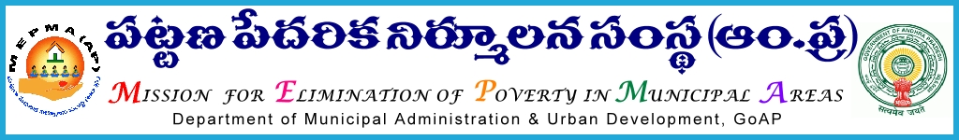
From To
The Mission Director, All the Project Directors of MEPMA
MEPMA, and
Hyderabad. PDs of GHMC, GVMC & VMC.

Lr. Roc. No. 40/BL/2010-11, Date: 31-07-2013.
Sub: Review meeting of Specialist Bank Linkage on 05-08-2013 at Conference Hall, H.O. @ 10.30am – Regarding.
@@@@
As per the instructions of Mission Director MEPMA, it is proposed to conduct the monthly Review meeting of District Level Specialists on 05-08-2013 at Conference Hall, H.O. @ 10.30am.
This meeting is being conducted with a specific reference to arriving and crediting of VLR amounts to the eligible SHG accounts, updation of SB & Loan accounts and reviewing of progress under Sthree Nidhi.
All the Specialists Bank Linkage are therefore requested to come prepared for the Review meeting with the latest progress in Disbursement of VLR out of the VLR amounts already released to the DPMUs.
They are further advised to bring along with them the details as per the agenda enclosed to this circular, for active deliberations during the meeting to be reviewed by the Mission Director and AMDs.
Further it is informed that the TA & DA as per the eligible norms shall be borne from out of the UCDN funds, State level reviews and workshops. The Project Directors of Krishna & Visakhapatnam are requested to arrange the TA & DA expenditure incurred in respect of the Specialists looking after Bank Linkage in VMC & GVMC respectively subject to the prevailing MEPMA norms from out of the UCDN component.
Sd/ - AMD(SD-I)
MISSION DIRECTOR

Agenda for discussion in Review Meeting of District Level Bank Linkage Specialists on 05-08-2013 at 10.30 am in MEPMA H.O. Hyderabad
……………………………………………………………………………
Bank Linkage & VLR:
- Review on Bank Linkage progress- District wise and ULB wise.
- Total VLR amount arrived by TCS in Phase-I and Phase-II upto 31-07-2013.
- VLR disbursement ULB wise.
- SB Accounts and Loan Accounts updation.
- VLR requirement data entry for Non-data sharing Banks.
- Conducting of TLBC meetings and updation position.
- Conducting of CBRM meetings and progress of recovery in overdues accounts ULB wise.
Pavala Vaddi:
Total PV released, credited, Balance to be credited or to be returned to MEPMA.

Sthree Nidhi:
- Progress in disbursement Sthree Nidhi loans.
Amount in Lakhs
No. of eligible TLFs | No. of eligible SLFs | No. of eligible SHGs | No. of SHGs accessed loans | Loan amount accessed | Overdues
 |  |  |  |  | No | Amount

- No. of TLFs and SLFs to be graded for Sthree Nidhi loans, which have completed the statutory requirements of audit

USEP & UWSP:
Targets and Achievement for 2013-14.
USEP |  |  |  | UWSP
Target |  | Perfromance |  | Target |  | Perfromance
No | Amount | No | Amount | No | Amount | No | Amount

