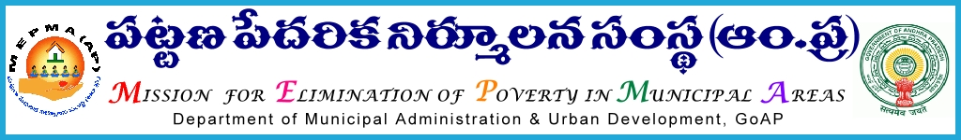
From To
Smt. Anita Ramachandran, IAS., All the Project Directors of MEPMA,
Mission Director, AC UCD GHMC &
POs of GVMC and VMC.

Lr. Roc. No. 40/BL/2012-13, Date: 28-03-2013.
Sir,
Sub: Monthly review meetings of Specialists Bank Linkage at Head Office on
06-04-2013-Reg.
Ref: Lr. Roc. No. 40/BL/2012-13, dated: 14-02-2013.

****

It has been decided to conduct a review meeting with all the District level Specialists –Bank Linkage at Head Office on 06-04-2013, with a specific agenda of finalizing the ULB wise, District wise SHG Bank Linkage action plan for the F.Y. 2013-14 and also reviewing the performance under SHG Bank Linkage, USEP & UWSP, and Sthree Nidhi for the year 2012-13. All the Bank Linkage specialists should come thoroughly prepared for the proposed meeting.
Accordingly you are advised to depute your Specialists to the review meeting with complete information and particulars on the above subjects, for active deliberations.
Further it is informed that the TA & DA as per the eligible norms shall be borne from out of the UCDN funds, State level reviews and workshops. The Project Directors of Krishna & Visakhapatnam are requested to arrange the TA & DA expenditure incurred in respect of the Specialists looking after Bank Linkage in VMC & GVMC respectively subject to the prevailing MEPMA norms from out of the UCDN component.

Sd/- for MISSION DIRECTOR

