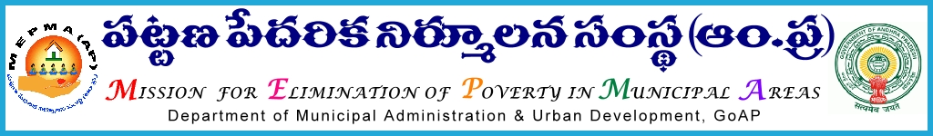
From To
Sri. P. Chinna Thataiah, All the District Collectors,
Mission Director, Andhra Pradesh.
APMEPMA
Guntur.

Lr.No: 235380/D1/IB/HFA/MEPMA, Dated: 10-11-2018
Sir,
Sub: MEPMA- APTIDCO – PAMY (U)-NTR NAGAR- Conducting District Level Bankers Meeting on or before 15-11-2018 for awareness on PMAY (U) - Housing beneficiaries scheme and processing of loans – Regarding.

Ref: Instructions of Hon’ble Chief Minister in the cell conference on 9-11-2018

***
I invite your kind attention to the reference cited, wherein Hon’ble Chief Minister during the review on PMAY(U)-NTR NAGAR through Cell Conference on 9th November 2018 has instructed to complete the disbursement of loans to the beneficiaries by 28th November 2018.
In this regard, it is required to create awareness on PMAY (U) – NTR NAGAR housing program to the bankers on the scheme, land value, infrastructure amenities etc. and arrange one to one interaction with the beneficiaries for speedy processing of loan disbursement.
Hence I request all the District Collectors to direct the concerned to conduct District Level Bankers Meeting on or before 15-11-2018 involving Project Directors (MEPMA), Lead District Managers (LDM), concerned Municipal commissioners, DCO (Bank Linkage), TMC / CMM (MEPMA) and APTIDCO officials.
Thanking you Sir,
Sd/-
Mission Director
APMEPMA
Copy to all the Project Directors in the State.
Copy to all the Municipal Commissioners concerned.
Copy to the Managing Director, APTIDCO, Vijayawada.
Copy to the General Manager (SDCB), APTIDCO, Vijayawada.
Copy submitted to the Principal Secretary to Government, MA&UD, Department. Velagapudi.
Copy submitted to the OSD to Hon’ble Minister, MA&UD.

