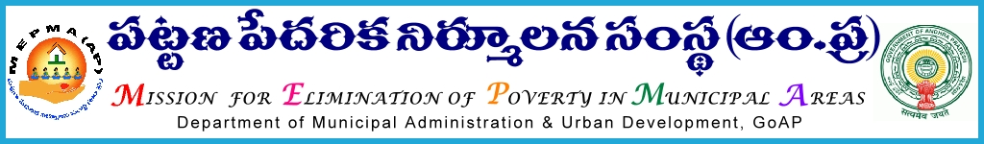
PROCEEDINGS OF THE MISSION DIRECTOR
Present: Smt Anita Ramachandran, I.A.S.,

Proc. Roc. No.1216 /2010-11 Date: 16-02-2013

Sub: MEPMA – Implementation of MEPMA activities – Action plan 2012-13 –Conducting General Body meetings of TLFs for the year 2012-13 – Release of funds – Orders issued– Regarding.

Read: 1) Action Plan of MEPMA for the year 2012-13.

2) Lr. Roc. No. A/59-6/IB/IKP-U/2008 dt. 25.09.2012 of the Project
Director, Chittoor district.

***
O R D E R:

In the reference 1st read, in the Action Plan of MEPMA for the year 2012-13, it is proposed to release an amount of Rs 22.5 lakhs @ Rs 15,000/- to each TLF towards conducting General body meetings to 150 TLFs under UCDN component of SJSRY.

In the reference 2nd cited, the Project Director, Chittoor district requested to release the budget to conduct the General Body Meetings of TLFs as it is mandatory in the By-laws.

During the year 2011-12, it is proposed to strengthen the existing slum level federations. CRP strategy was being implemented in all the slums excluding mission cities for strengthening SHGs and formation of slum level federations (SLFs), through utilizing the technical expertise from rural areas. Further, after taking of series of capacity building programmes for strengthening of SHGs and SLFs and in the ref. 1st cited , instructions were issued for conducting GB meetings of TLFs.
Accordingly, it is proposed to release an amount of Rs 22,50,000/- towards conducting of General Body meetings of TLFs
There are 211 TLFs in all 171 ULBs as on 5th Nov,2012. Hence details are worked out to release Rs. 15000/- to each TLF for 150 TLFs existed in 125 ULBs as per the Action Plan towards conducting of GB meetings of TLFs for the year 2012-13.

Name of the District | No. of ULBs as per online dated 5.11.2012 | No. of TLFs for which amount proposed in the existing 125 ULBs Now | Amount proposed for GB meetings @ Rs. 15000/- per each TLF
Adilabad | 7 | 7 | 105000
Anantapur | 12 | 8 | 120000
Chittoor | 8 | 9 | 135000
East Godavari | 12 | 16 | 240000
Guntur | 13 | 16 | 240000
Kadapa | 9 | 10 | 150000
Karimnagar | 11 | 8 | 120000
Khammam | 6 | 7 | 105000
Krishna | 8 | 6 | 90000
Kurnool | 10 | 7 | 105000
Mahaboobnagar | 9 | 4 | 60000
Medak | 6 | 5 | 75000
Nalgonda | 8 | 4 | 60000
Nellore | 6 | 5 | 75000
Nizamabad | 4 | 5 | 75000
Prakasam | 8 | 4 | 60000
Ranga Reddy | 2 | 2 | 30000
Srikakulam | 5 | 5 | 75000
Visakhapatnam | 4 | 2 | 30000
Vizianagaram | 4 | 4 | 60000
Warangal | 6 | 7 | 105000
West Godavari | 9 | 7 | 105000
Cantonment | 1 | 1 | 15000
GHMC | 1 | 1 | 15000
GVMC | 1 | 0 | 0
VMC | 1 | 0 | 0
Total | 171 | 150 | 2250000

All the Project Directors are requested to incur the above expenditure through TLFs only. The guidelines are herewith enclosed for ready reference.

Project Directors , MEPMA mentioned in para above are requested to book the expenditure under a separate head of A/c UCDN –strengthening of TLFs . They are requested to utilize the same for the purposes mentioned, duly following the guidelines and module for Town level federation was also placed on website www.apmepma.gov.in for further necessary technical support.

The Finance Manager is requested to release the amount of Rs. 22,50,000/- (Rupees Twenty Two Lakhs Fifty Thousand only ) under UCDN component – TLF strengthening by way of E-transfer in favour of the Project Directors, IKP urban as mentioned in the statement shown above.

Sd/-Anita Ramachandran MISSION DIRECTOR

Copy to Finance Manager, MEPMA for n/a

The Project Director, MEPMA _ _ _ _ _ _ _ _ _ _ _ District
Copy to the Collector and District Magistrate concerned.

