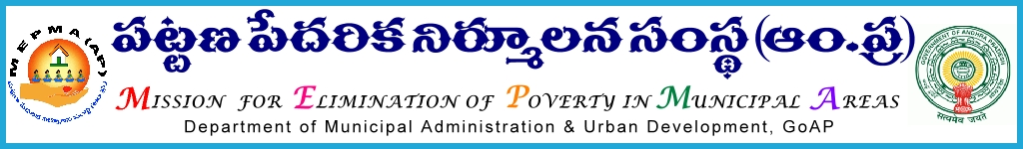

From, To,
Smt Anita Ramchandran, I.A.S., The Project Directors,
Mission Director, MEPMA MEPMA,
Hyderabad Srikakulam,Visakhapatnam, Guntur, Prakasam,Chittoor,
Kadapa,Khammam, Mahabubnagar, Medak, Nalgonda , Nizamabad, & Warangal districts

Lr. Roc. No 6049/09/D1 dated 05 -01-2013
<<
Sub:- | MEPMA – Implementation of IB activities – Release of funds towards conduct of District Level Workshops /Reviews/Video Conferences with CRPS– Details not furnished –Reg.
<><><>

I invite the attention of the Project Directors, MEPMA, mentioned in the address entry to the subject cited wherein you have been informed to send the budget available under head Workshops /Reviews/Video Conferences - CRPS under Community Structure Component so as to work out the requirement for the Year 2012-13. Inspite, some of the Project Directors not submitted the details so far.

Hence, the Project Directors, MEPMA, Srikakulam, Visakhapatnam, Guntur, Prakasam, Chittoor, Kadapa, Khammam, Mahabubnagar, Medak, Nalgonda, Nizamabad & Warangal districts are instructed to submit the budget available under the respective head duly certifying by the concerned Project Director so that the amount will be released to the districts.

. Sd/- Anita Ramchandran
MISSION DIRECTOR

