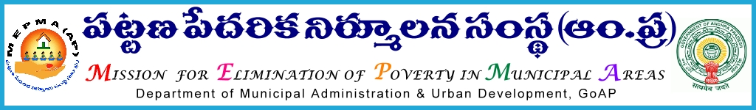
From To
The Mission Director, The DPMUs /
MEPMA, Mission Cities.
Hyderabad.

Lr. Roc. No. 15183/D1/BL/2012/ PavalaVaddi, date: 20-04-2013
Sub: PavalaVaddi – Total PavalaVaddi released to the DPMUs since 2007-08 to
2012-13, total amount credited to SHG accounts and balance available – Returning of balance amount to MEPMA H.O – Requested – Regarding:

@@@@

It is to inform that, a statement containing total PavalaVaddi released since inception, Credited to SHG accounts and balance available with DPMUs / Mission Cities is herewith enclosed. You are instructed to credit the balance amount to the eligible SHGs or return the same to H.O. Further you are also advise to ensure that existing PavalaVaddi account is thoroughly reconciled with the receipts / disbursement and submit UCs to that effect and ensure to close the PavalaVaddi account immediately.
Khammam PD is advised to return the balance amount of Rs.15.22 lakhs after releasing of Rs.22.50 lakhs to DRDA Khammam on account of Bhadrachalam ULB.

Sd/-
MISSION DIRECTOR
Encl: Statement of total PV released, credited to SHG accounts
and balance to be credited / to be returned.

