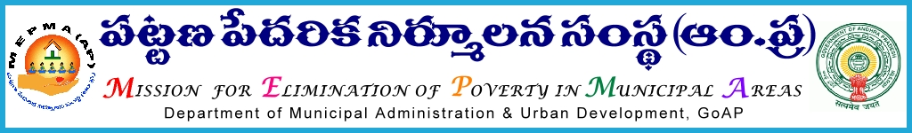

From To
Smt. Anita Ramachandran, I.A.S., All Project Directors,
Mission Director, MEPMA A.P State.
Hyderabad.

Sir,

Lr Roc. No.4554MEPMA/ D1 dated 26.11.2014

Sub:-MEPMA- conducting of training programs to the Town Project Officers/Town Mission Coordinators and Community organizers, CLRPs from NULM towns on Financial Management, SHG livelihoods, EDP trainings & NULM component wise review –– deputing the functionaries – orders – issued - regd..

* * *
It is proposed to conduct training programme on Financial Management, SHG livelihoods & Convergence to the Town Project Officers/Town Mission Coordinators and Community organizers, CLRPs from NULM towns for 2 days at RCUES during Dec’2014. The details are as follows:

Name of the district | No.of COs/TMCs,TPrOs (NULM) | Date of conduct of the programme | No.of participants ( 3 from each TLF – President, Secretary & TLF Resource person )
Srikakulam | 5 | 5th to 6th Dec’2014 (APITCO,IB SRP ,MEPMA staff) | 54 Nos in 1 batch at RCUES,O.U, Hyderabad.
Vizianagaram | 5
VSP | 0
East Godavari | 27
West Godavari | 17
Total | 54

Name of the district | No.of COs/TMCs,TPrOs (NULM)) | Date of conduct of the programme | No.of participants ( 3 from each TLF – President, Secretary & TLF Resource person )
Guntur | 33 | 9^{h} to 10th Dec’2014 (APITCO,IB SRP ,MEPMA staff) | 70 Nos in 2 batches
Nellore | 13
Krishna | 12
Prakasham | 12
 | 70
Anantapur | 26 | 11th to 12th Dec’2014 (APITCO,IB SRP ,MEPMA staff) | 79 Nos in 2 batches
Chittoor | 16
Kurnool | 22
Kadapa | 15
 | 79 Nos

Hence all the Project Directors are instructed to depute the functionaries and their travel charges may be paid out of available funds under NULM – as per norms in force and shall ensure they would report at the venue by 10.00 AM on the scheduled dates without fail.

Yours faithfully,
Sd/-
Mission Director, MEPMA

Encl: Schedule of the programme .

Schedule of the training programme to COs/TMCs/TPrOs during Dec’2014.

1st day
1 | 10.00 -10.30 | Registration , Prayer | MEPMA
2 | 10.30 – 10.45 | Opening remarks | MD ,MEPMA
3 | 10.45-11.15 | NULM | AMD,MEPMA
Tea Break
4 | 11.15-12.00 | SHG livelihoods | APITCO
5 | 12.00-12.15 | EDP trainings
6 | 12.15-12.45 | Facilitation of CBOs for preparation of business plans and project reports for IG activities
6 | 12.45-1.30 | Other issues
1.30-2.30 Lunch
7 | 2.30-3.30 | Financial Management of CBOs – Role of promoting organizations. | IB RP/SMC
8 | 3.30-5.30 PM | Personality Development & leadership skills | SMC

S.NO | TIME | TOPIC | FACILITATOR
2nd day- Review on MEPMA
1 | 10.00 -10.30 | Registration , Prayer | MEPMA
2 | 10.30 – 10.45 | Feedback on earlier session | MEPMA
3 | 10.45-11.30 | NUHM – Role of field functionaries and CBOs | SMC
Tea Break
4 | 11.30-12.00 | Social Mobilization & Institution development | SMC
5 | 12.00-12.30 | Bank linkages- Universal Financial inclusion-sthreenidhi | SMC
6 | 12.30-1.30 | Street vendors – shelters for Urban Homeless | SMC
1.30-2.30 Lunch
8 | 2.30-3.15 PM | SEP (I) and (G) /SHG livelihoods | SMC
9 | 3.15-4.30 PM | EST&P and concluding session | DD,EST&P

