WEB Process of SEP (I & G)
Work Flow -Process:
TPRO / TMC Login:
- Application Data Entry in TPRO Login by DEO.
- Up load – Ration Card & SLF Resolution.
- Data Entry details verification in TPRO Login and forward to Commissioner Login.
Commissioner Login:
- Update Task Force committee recommendation status for each applicant to bank else forward to with reasons and of Bank Name & Branch Name and IFSC code.
- UP load – Task Force committee recommendation Format.
- A recommendation letter shall be generated with Bank wise approved applicants in a prescribed format.
- Bank sanction of Applications provision of entry in Commissioner’s Login.
- Banker sanctioned details to be forwarded to P.D. login for District Collector’s approval.
- Forward Collector approval list to field functionaries.
- Update beneficiary wise grounding details like with photo date of grounding loan account number, loan amount, rate of interest and number of installments.etc.,
- Up load repayment status.
Project Director Login:
- Approve & generate the proceeding of Sanctioned Applications for Collector’s approval.
- After Collector approval sanctioned applications forward to Commissioner login for Grounding details entry.
- Generate proceeding for Collector approval for quarter wise interest Subvention for the beneficiaries approved by Project Director.
- Provision shall be given to upload scanned copy of collector proceeding.

MIS SMC (LH) AMD MISSION DIRECTOR

SEP-I Entry Format User Manual:
Step-1:
Go to www.apmepma.gov.in website and click on Department Login Enter ULB login id and Password
Click on SEP-I Forma go to Application Forma click on the ADD Application
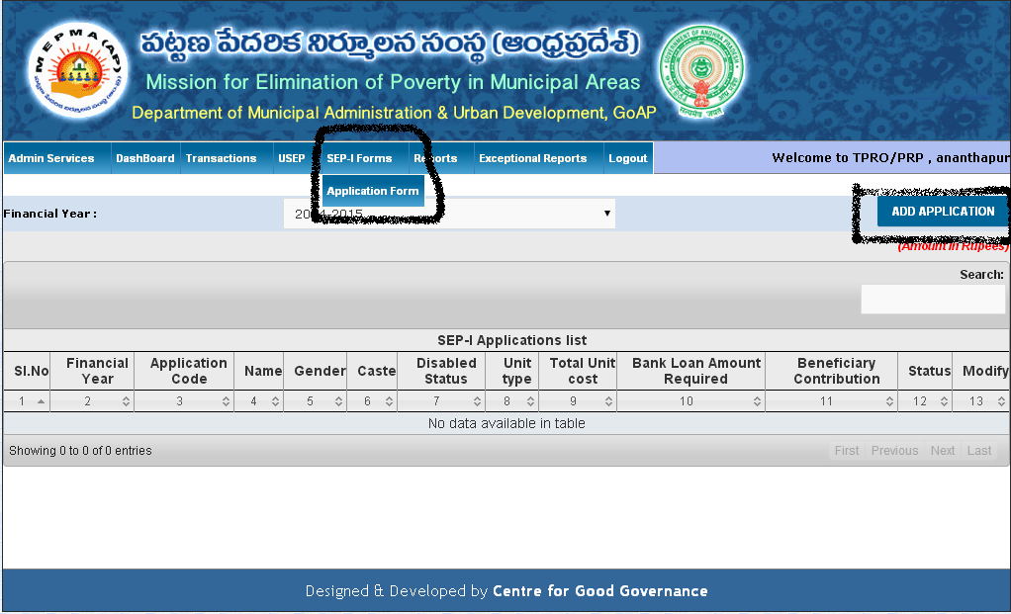

Step-2:
Enter Basic information in Application form and click on Submit Button your application form is saved.
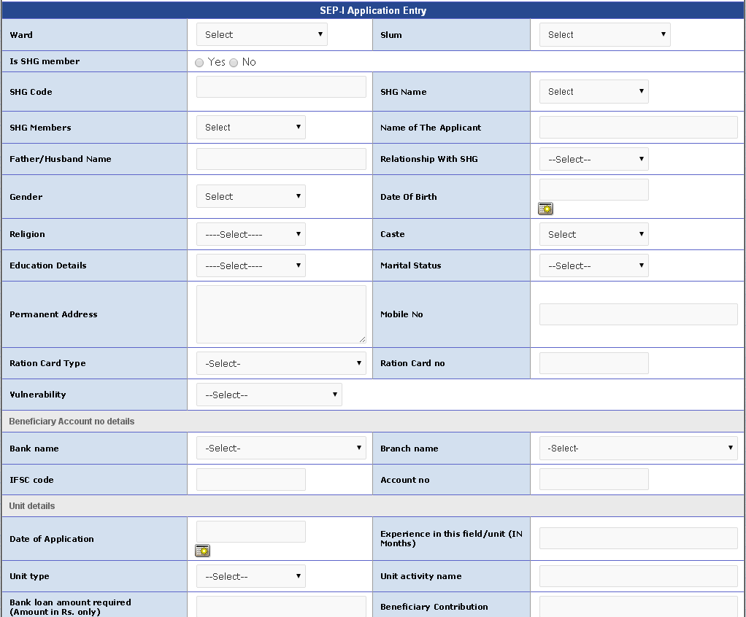

After Submit the application your application form is forward to Commissioner login for approval

STEP-3:
Goto Commissioner login click on the SEP goto SEP-I Form in this login total 4 steps are there first 3 steps forward to application form after approval of commissioner and Banker then forward to PD approval of Sanction of Application.
These 3 steps are completed then application form is Sanction list in Reports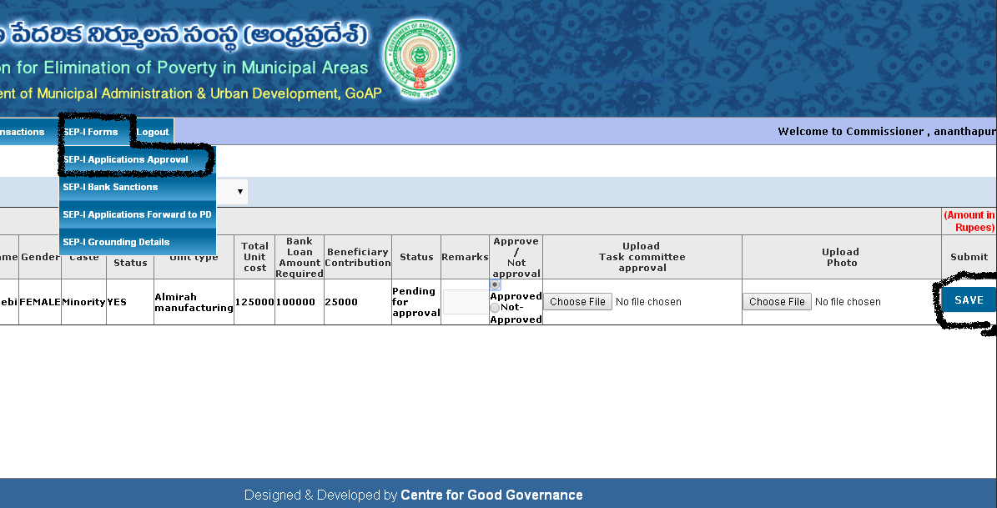

Then the Fourth Step is Enter the Grounding details after sanction of PD

Step-4:
Go to PD login for sanction of application and generate the proceedings in this login Note file generated for collector approval .
PD approved applications forward to commissioner login for enter the Grounding details

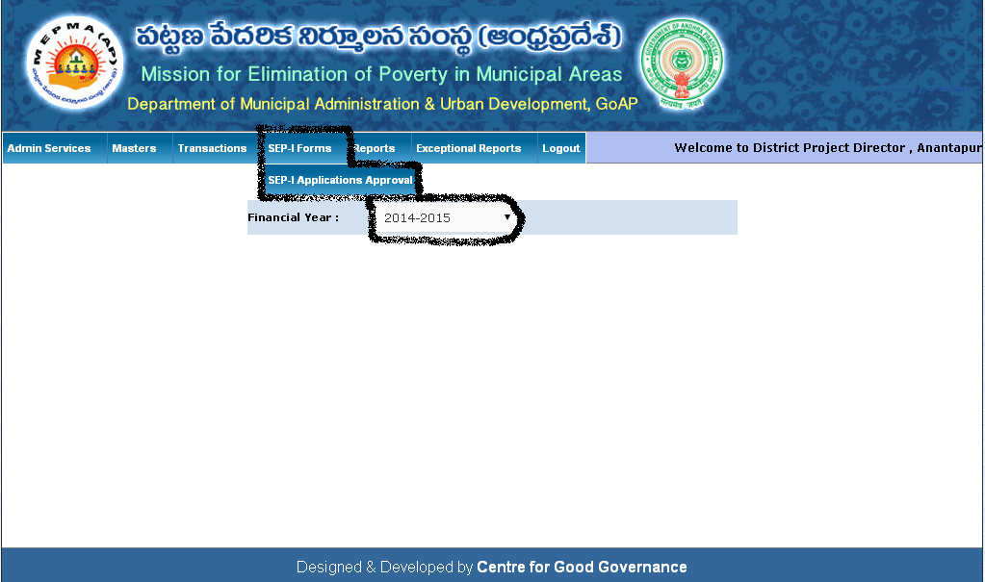
Step-5: Enter the Grounding details in Commissioner login
After grounding the application then forward to TCS site for calculation of SEP-I Interest and provision the entry form in this site regular repayment.

