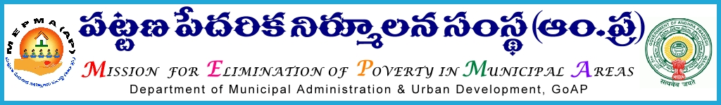
From To
The Mission Director, All the Project Directors of MEPMA,
MEPMA, PDs & Pos of GVMC & VMC,
Hyderabad. MEPMA,
Andhra Pradesh.

Lr.Roc.No. 002 /2015/dated 14.05.2015
Sir,

Sub:- MEPMA – Video Conference with PDs on Aadhar Seeding & Capital Infusion to be held on 15.05.2015 from 09.30 AM to 11.00 AM – Requested to attend - Reg.

***

It is proposed to conduct a Video Conference by the Mission Diretor, MEPMA with all the Project Directors & the PDs & Pos of GVMC & VMC to review the progress on Aadhar Seeding and to discuss modalities and guidelines with regard to Capital Infusion on 15.05.2015 from 09.30 AM to 11.00 AM .

The PDs are advised to attend the same with all the up to date particulars along with their TMCs and DMCs concerned.
They are further requested to make sure that the Video Conference hall at the respective District Collectorates is kept open by 09.15 AM, by requesting the concerned staff, as the review commences by 09.30 AM sharp.

Yours faithfully,
Sd/-
for MISSION DIRECTOR

