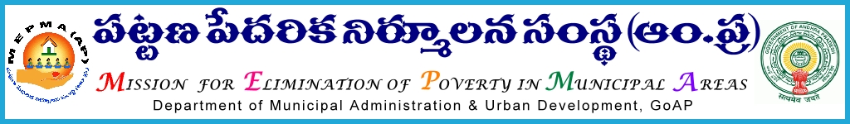
From To
Sri Solomon Arokiaraj, I.A.S., All Project Directors ,
Mission Director,MEPMA MEPMA.
Hyderabad. Govt.of AP, Hyderabad.

Sir,
Lr Roc. No. IB Action plan /2015 dated 1.7.2015.

Sub:- MEPMA – Action plan for 2015-16 – certain instructions – issued - Regd..

Ref: - 1.Action plan already furnished on the basic activities under SM&ID from all the districts.
2. Draft detailed action plan with financial norms

* * *
It is to inform that, Action plan for SHG/SLF and TLF formation, defunct group revival , revival of defunct groups, grading of SHGs,Parishkara kendrams etc., from the districts was furnished to MEPMA office. Based on the priorities during this year , detailed activity wise plan at state level was arrived and a copy of the same is enclosed for taking further necessary action.

All the PDs are requested to go through the action plan under SM&ID with DMCs and the conduct meeting with CD staff of ULBs and prepare action plan ULB/ district wise. For SHG formation, SLF formation, defunct group revival, TLF formation- targets were already communicated and kept online and the same may be followed. Nomadic groups – based on the potential, DMCs can specify the number existing and new groups.

PDs are instructed to issue necessary instructions to SMC for preparing action plan at ULB level in consultation with SLFs and TLFs and send the district wise action plan so as to enable this office to allocate the district wise funds under SM&ID. For any further clarifications in this regard , you may contact SMCs (IB) , and DMC (Sri Prasad ) of this office. This may be treated as MOST URGENT and action plans have to be furnished to MEPMA office before 4th of July’2015.

Yours faithfully,
Sd/-
for Mission Director, MEPMA.

For Model SLFs and TLFs separate guidelines would be communicated

