Most Urgent:
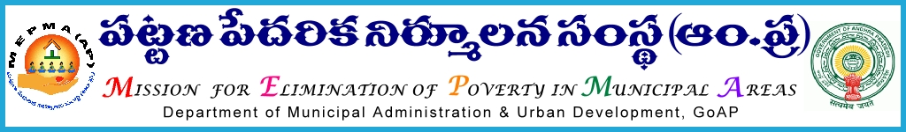
From To
Sri Solomon Arokia Raj, I.A.S., All Project Directors ,
Mission Director,MEPMA MEPMA.
Hyderabad. Govt.of AP, Hyderabad.

Sir,
Lr Roc. No.Action plan/2015-16 dated 3.7.2015.

Sub:- MEPMA – Social Mobilization & Institution Development – Utilization of funds under NULM – particulars to be furnished - Regd..
Ref:- This office Lr Roc No /2015 dated 1.7.2015.

* * *
It is to inform that, as per the guidelines communicated by GOI, funds were allocated to all the PDs under SM&ID component. Further in the ref. cited all the PDs were requested to send the action plans with financial requirement for the year 2015-16. In this connection all the PDs are requested to furnish the following details related to expenditure particulars under SM&ID component – so as to enable this office to allocate funds for the year 2015-16 under NULM.

Component | Activity | Amount allocated under SM&ID | Amount incurred | Balances available | Amount spent towards trainings ( enclose details) | Amount available with TLF as balance for this year 2015-16 | Remarks
Social Mobilization &Institution Development | Funds released to TLFs towards RO funds under NULM
 | Revolving fund to SHGs
 | Revolving fund to SLFs
 | City Livelihood Centres
 | Any other activity (specify)

All the PDs are instructed to send the above particulars before 6th of July’2015 in consultation with concerned DMCs, IB and Accounts section – so as to allocate funds for the year 2015-16. This may be treated as Most Urgent.

Yours faithfully,
Sd/-
for Mission Director, MEPMA.

