Most Urgent:
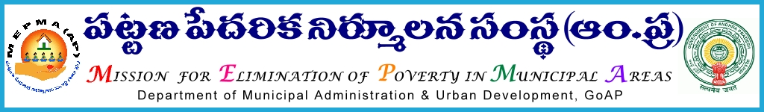
From To
Sri Solomon Arokia Raj, I.A.S., All Project Directors ,
Mission Director,MEPMA MEPMA.
Hyderabad. Govt.of AP, Hyderabad.

Sir,
Lr Roc. No.Action plan/2015-16 dated 3.7.2015.

Sub:- MEPMA – Social Mobilization & Institution Development – Utilization of funds under NULM – particulars to be furnished - Regd..
Ref:- This office Lr Roc No /2015 dated 1.7.2015.

* * *
It is to inform that, detailed guidelines were communicated to all the PDs regarding establishment of Parishkara kendrams and to meet the expenditure of Rs 10000/- per centre towards infrastructure & other items in Parishkara kendrams under SM&ID component. Online formats would be placed in MEPMA website before 10th of July’2015. Hence all the PDs are requested to send the progress in following two formats.

1.Details of District level committee members

Sl No | Name of the district committee member | designation | Representation as

ULB Committee:
Name of the NULM ULB | Details of the Social action committee members at ULB level | Location & address of the Parishkara Kendram | Whether infrastructure procured by TLFs and details | No.of social action committee meetings conducted from April’2015 with dates | No.of cases registered by the committees | No.of cases solved by the committees
 | 1 |  |  |  | ( to be sent month wise from April’2015)
 | 2
 | 3
 | 4
 | 5
 | 6
 | 7
 | 8
 | 9
 | 10
All the PDs are instructed to send the above particulars before 7th of July’2015 in consultation with concerned DMCs and also issue necessary instructions to DMCs for regular monitoring of the above kendrams and submit a weekly report in the above matter.

Yours faithfully,
Sd/-
for Mission Director, MEPMA

