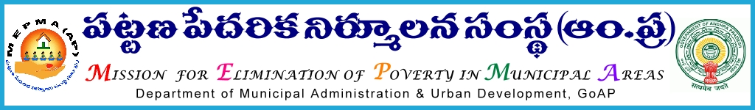

From To
Sri Solomon Arokia Raj, I.A.S., All Project Directors ,
Mission Director,MEPMA MEPMA.
Hyderabad. Govt.of AP, Hyderabad.

Sir,
Lr Roc. No 250-IT /2015 dated 4.7.2015.

Sub:- NULM – training to DEOs on MIS aspects of various components of NULM – deputing the personnel – requested - Regd..

* * *
It is proposed to conduct training on MIS aspects to all Data Entry Operators in NULM ULBs at APCOB, ICM complex , Rajendra Nagar, Hyderabad on 7th and 8th of July’2015. Hence all the PDs are instructed to depute DEOs of NULM ULBs to APCOB,ICM , Rajendranagar Hyderabad for the said training at Hyderabad and also ensure that they would report at the venue by 10.00 am on 7.7.2015 without fail. TA&DA of the participants may be met from CBT funds of NULM funds as applicable under MEPMA norms. Resource persons from MoHUPA,Government of India would be imparting the said training.

Venue address:APCOB, ICM complex, Rajendra nagar, Hyderabad.

Contact person: Sri Chandra Sekhar Reddy, MIS Manager – 9701381317.

Yours faithfully,
Sd/-
Mission Director, MEPMA.

Copy to the Director, APCOB,ICM,Hyderabad for taking n/a in providing logistic facilities .
Copy submitted to GOI , for favour of information and deputing the resource persons.

