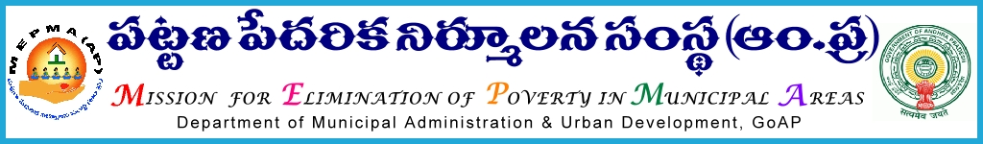

Office of the Mission Director,
MEPMA, A.P., Hyderabad .
CIRCULAR
Lr.Roc.No. 685/2012/E1 Dt: -07-2015
Sub:- MEPMA- Estt- NULM-MEPMA-Utilization of funds under NULM-particulars to be furnished-Reg.
****
It is to inform that, as per the guidelines communicated by GOI, funds were allocated to all the PDs for the year 2014-2015. All the Project Directors are requested to furnish the following details under NULM & Non-NULM immediately to this office so as to allocate fu nds for the y ear 2015-16.
S.No | Name of the component/Scheme | Amount allocated till 2014-15 | Expenditure  incurred | Balance funds available | Funds required for the 2015-16 as per the targets fixed | Net funds required  (5-6) | Remarks
1 | 2 | 3 | 4 | 5 | 6 | 7 | 8
NULM
1 | Social Mobilisation and Institution Development(SM&ID)
2 | Employment through Skills Training & Placement(EST&P)
3 | Self Employment Programme(SEP)
 | SEP- Individual
 | SEP-Group
4 | Support to Urban Street Vendors(SUSV)
5 | Shelter for Urban Homeless(SUH)
6 | A&OE
7 | IEC
NON-NULM
1 | National Urban Health Mission(NUHM)
2 | CRCs & MSBs
3 | SECC
4 | RAY & USHA
All the Project Directors are instructed to send the said particulars before 9th of July, 2015 both in hard & soft copies so as to allocate funds for the year 2015-16. This may be treated as MOST URGENT.

For MISSION DIRECTOR
To
The all Project Directors, DPMUs in the State

