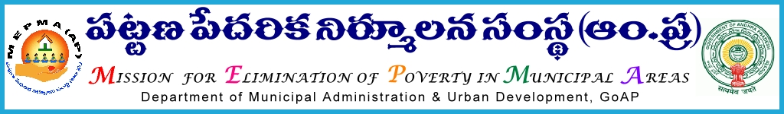

From To

Sri Solomon Arokiaraj, I.A.S., All Project Directors ,

Mission Director, MEPMA MEPMA.

Hyderabad. Govt.of AP, Hyderabad. The PD GVMC,VMC

Sir,

**Lr Roc. No. 548/C/2015 - dated 6.7.2015.**

**Sub**:- MEPMA – Two day workshop on Entrepreneurship& Marketing on July 8th and 9th 20015 at ICM – APCOB, Rajendranager,Hyderbad – Deputing the SHG Entrepreneurs from AP,MEPMA – orders – issued Regd.

* * *

It is to submit that, MEPMA has proposed to conduct two day workshop on Entrepreneurship & Marketing to SHG Entrepreneurs on 8th and 9th of July ‘2015 at ICM – APCOB,Rajendranager,Hyderabad .

The details are as follows.



The PDs are directed to depute the above SHG members along with their products for the said workshop and pay travelling allowances as applicable and ensure that they shall report at the said venue by 9.30am sharp on the scheduled date .

Yours faithful

Sd/-

for Mission Director, MEPMA.