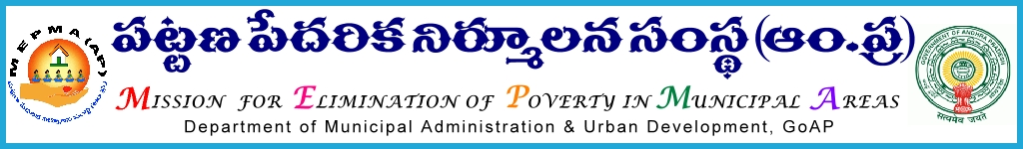
From To
Sri Solomon Arokiaraj, I.A.S., All Project Directors,
Mission Director, MEPMA MEPMA.
Hyderabad. Govt.of AP, Hyderabad.

Sir,
Lr Roc. No. 548/C/2015 - dated 24.8.2015.

Sub:- MEPMA – One day training program on Strengthening of City Livelihood Centers on September’ 1st and 2nd 20015 at MEPMA conference hall, Hyderabad – Deputing the CLC staff(DEO, Manager)and TMCs from NULM Towns – orders – issued Regd.
* * *
It is proposed to conduct one day training program to CLC staff (Manager, DEO),TMCs on the concept and functioning process of City Livelihood Centers on 1st and 2nd of September ‘2015 in MEPMA conference hall, Hyderabad from 9.30 AM.

The details are as follows.
Date of training | Name of the Districts | No. Of CLCs | No. Of Participants
1/9/2015 | Ananthapur | 5 | 15
 | Chittoor | 3 | 9
 | Kadapa | 1 | 3
 | Kurnool | 3 | 9
 | Nellore | 1 | 3
 | Prakasam | 2 | 6
 | Total | 15 | 45
2/9/2015 | Guntur | 5 | 15
 | Krishna | 2 | 6
 | West.Godavari | 3 | 9
 | East. Godavari | 2 | 6
 | Vizainagaram | 1 | 3
 | Srikakulam | 1 | 3
 | Total | 14 | 42
 | Grand Total | 29 | 87

The PDs are directed to depute the said staff members for the said Training program and pay travelling allowances as applicable and ensure that they shall report at the said venue by 9.30am sharp on the scheduled date .

Yours faithful

Sd/-
For Mission Director, MEPMA.

