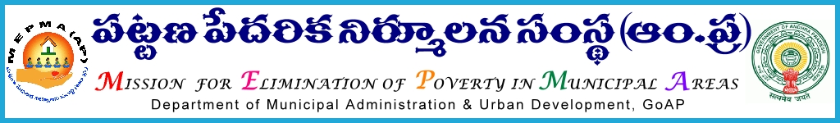

From To
Sri Solomon Arokia Raj ,I.A.S., The Project Directors,
Mission Director,MEPMA MEPMA.
Hyderabad. Govt.of ÄP, Hyderabad.
Sir,
Lr Roc. No. 4265/APMAS/2015 dated 06.09.2015.

Sub:- MEPMA – Sthreendihi – nominating the TLF presidents for attending the 1st Annual General Body meeting on 08.09.2015 at Vijayawada - instructions – issued - regd.
Ref: Lr No SN / GB meeting / 2015 / 76 dated 21.8.2015.
.
* * *

MD,AP Sthreenidhi has proposed to conduct 1st Annual General Body meeting on 8th Sep’2015 at Vijayawada . Hence Project Directors are requested to nominate the TLF Presidents for the above GB meeting and ensure that they report by 9.30 AM at A1 Convention Centre on 8th Sep’2015.The travelling allowances would be borne from Sthreenidhi.

Yours faithfully,
Sd /-
Additional Mission Director, MEPMA

