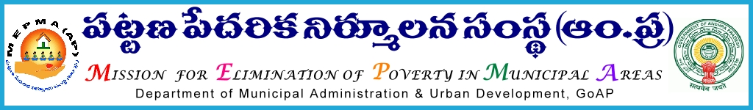
From To
Sri Solomon Arokiaraj, I.A.S., All Project Directors ,
Mission Director, MEPMA MEPMA.
Hyderabad. Govt.of AP, Hyderabad. The PD GVMC,VMC

Sir,

Lr Roc. No. 956/C/2015 - dated 14.9.2015.

Sub:- MEPMA – Three days training program on Generic Medical Stores on September 114^{h} to 27th 20015 at TTDCs Regional level (Visakapatnam,Vijaywada,Tirupathi,Kurnool) – Deputing Staff members from AP,MEPMA – orders – issued Regd.

* * *
It is to submit that, SERP has proposed to conduct three days training program on Generic Medical Stores. During this three days two days will be detailed session on pharmacy subject ABOUT management and maintenance of pharmacy stores by ‘’ go getter –‘’ training agency and one day will be complete session by the officials of Government Departments like drug control department, commercial department, and labor department, to update their department rules and regulations to newly selected pharmacists anchor persons and community. Regarding software AP On line will be attending to demonstrate software issues for Generic Medical shops.
Therefore the PDs, Vizag. Krishna,Chittoor,and Kurnool are requested to co ordinate with concerned district level departments like Drug Control Department. Commercial Taxes Department and Labor Department to attend this training program to provide required orientation to the participants.

The details of the participants:

- Pharmacist for proposed New Generic Shop
- Computer Operator for proposed New Generic Shop
- 2 Representatives of the concerned Town Level Federations
- TMC/TPrO of the concerned town

The PDs are directed to depute the said members for the said workshop and pay travelling allowances as applicable and ensure that they shall report at the said venue by 9.30am sharp on the scheduled date .

For any further details and clarifications Mr. Gurunadh may be contacted on his Mobile number 7702221046.

The TPrO/TMCs, pharmacists and members of TLF who underwent training in Vijayawada on Generics on 10th and 11th August need not attend the training.

Encle : Details of the training program

Yours faithful
Sd/-
for Mission Director, MEPMA.
Training Schedule for pharmacists, anchor persons and Community
S.NO | DISTRICT | VENUE | DATE | TRAINING AGENCY
1 | SRIKAKULAM | Visakhapatnam TTDC | 14-09-2015 to 16-09-2015 | GO GETTERS Training Agency
2 | VIZIANAGARAM |  |  | GO GETTERS Training Agency
3 | VISAKHAPATNAM |  |  | GOVT DEPARTMENTS/AP online
4 | EAST GODAVARI | Vijayawad TTDC
5 | KRISHNA |  | 18-09-2015 to 20-09-2015 | GOVT DEPARTMENTS/AP online
6 | WEST GODAVARI |  |  | GO GETTERS Training Agency
7 | GUNTURU |  |  | GO GETTERS Training Agency
8 | ONGOLE | Tirupathi TTDC | 21-09-2015 to 23-09-2015 | GOVT DEPARTMENTS/AP online
9 | NELLORE |  |  | GO GETTERS Training Agency
10 | Chittoor |  |  | GO GETTERS Training Agency
11 | KADAPA | Kurnool TTDC | 25-09-2015 to 27-09-2015 | GOVT DEPARTMETS/AP online
12 | KURNOOL |  |  | GO GETTERS Training Agency
13 | ANANTAPUR |  |  | GO GETTERS Training Agency

