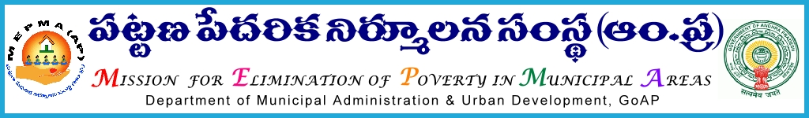

From To
Sri P.Chinna tataiah, The Project Directors,
Special Director,MEPMA MEPMA.
Hyderabad. Govt.of ÄP, Hyderabad.

Sir,
Lr Roc. No. 681/NULM/2015 dated 30.9.2015.

Sub:- MEPMA – Social mobilization & Institution Development – workshop on performance indicators to the field level functionaries in MEPMA – on 3rd Oct’2015 – deputing the concerned - requested - Regd..
Ref: - 1.Minutes of the meeting dated 19.6.2015 & 20.8.2015 at Vijayawada on IB activities including rehabilitation of ragpickers in urban areas .

* * *
It is proposed to conduct workshop with the field functionaries and NGOs having expertise in social development aspects on 3rd Oct’2015 at 10.30 A.M at Institute of Chiguru, Krishna Karakatta, Tulluru Road for discussing on aspects of role clarity of the field functionaries and performance indicators. The following are the details of the participants to be deputed for the above workshop:

District Mission coordinators (IB) & (LH) | ADMC – Social Security , Health and Nutrition | Town Mission Coordinators/TPrOs | Community Organizers | SLF Resource persons
DMC IB from Prakasham , Chittoor & Visakhapatnam. | ADMC,Social security from  Guntur, GVMC,Kadapa | One TPrO – Anantapur district.  One TMC from Kurnool district  2 TMCs from East Godavari.  1 TMC from Nellore  1 TMC from Vzm. | @ One from each district | @ one from each district
DMC LH from East Godavari, Srikakulam & Anantapur | ADMC, Krishna,Kurnool,West Godavari

All the Project Directors are requested to depute the above personnel for the said workshop. TA & other allowances may be paid as per norms of MEPMA from CBT funds under NULM.

PD,Krishna is requested to make necessary arrangements and meet the expenditure from CBT component of NULM.

Yours faithfully,
sd/-
for Special Director, MEPMA

