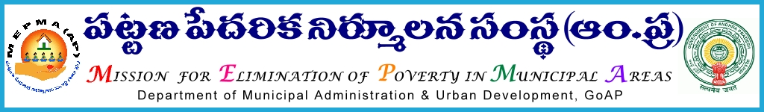

From To
Sri P.Chinatataih, The Project Directors,
Special Director,MEPMA MEPMA.
Hyderabad. Govt.of ÄP, Hyderabad.

Sir,
Lr Roc. No. 4265/APMAS/2015 dated 6.9.2015.

Sub:- MEPMA – Training to SHG members on Capital Infusion & other activities of MEPMA in Non-NULM towns – certain instructions – issued - regd.
Ref: 1.This office circular No 681/SHG-RF/NULM/MEPMA dated 29.7.2015.
2.PDs conference held on 28th and 29th Sep’2015 at Vijayawada.
* * *

In the reference cited, detailed guidelines were communicated to all PDs regarding conducting of orientation programmes to all SHG members at slum level through CRPs and PDs have requested to clarify the mode of release of funds to Non-NULM , as there are no funds available under Non-NULM. In this connection PDs are requested to release the required funds for the above purpose to TLFs from the available funds subject to recoupment from Non-NULM funds soon after they are received and ensure that training programmes would be completed by 30th Sep’15, without fail.
PDs are also requested to utilize the CLRPs as CRPs in non-NULM towns and pay remuneration for 18 days through TLFs @ Rs 175/- per day of work or training

Yours faithfully,
sd/-
Special Director, MEPMA

