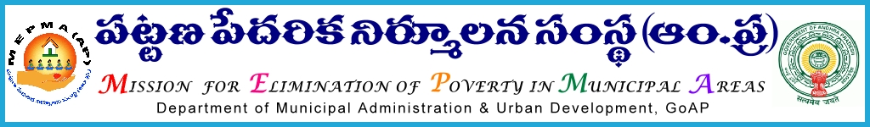

From To
Sri P.Chinatataih, The Project Directors,
Special Director,MEPMA MEPMA.
Hyderabad. Govt.of ÄP, Hyderabad.

Sir,
Lr Roc. No. 4265/APMAS/2015 dated 1.10.2015.

Sub:- MEPMA – Training to SHG members on Capital Infusion & other activities of MEPMA in Non-NULM towns – certain instructions – revised – issued - regd.
Ref: 1.This office circular No 681/SHG-RF/NULM/MEPMA dated 29.7.2015.
2.PDs conference held on 28th and 29th Sep’2015 at Vijayawada.
3.This office Lr Roc No 4265 /APMAS dated 6.9.2015.
* * *

In the reference cited, PDs were requested to release the required funds for the training programme to SHG members on capital infusion to TLFs from the available funds subject to recoupment from Non-NULM funds soon after they are received and ensure that training programmes would be completed by 30th Sep’15, without fail. In view of the circumstances of the fund position to Non-NULM towns, PDs are instructed not to release the funds to Non-NULM towards the above purpose . In case if it is released, recoup to the budget from which it was released and intimate the action immediately.

Yours faithfully,
sd/-
Special Director, MEPMA

