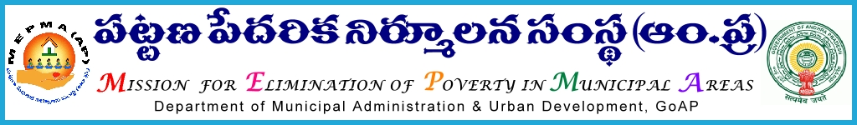

From To
Sri P.Chinatataih, The Project Directors,
Special Director,MEPMA All districts .
Hyderabad. Govt.of ÄP, Hyderabad.

Sir,
Lr Roc. No. 16/Gender/ D1- 2015 dated 1.10.2015.

Sub:- NULM– CBO strengthening through improved system of monitoring and implementation of Urban Poverty alleviation activities – ToT training to Master trainers and DMCs IB - Review on IB activities - certain instructions – issued - regd.
Ref:- 1.PDs conference dated 28th and 29th Aug’2015 & This office circular No 2096/IB dated 14.9.2015.
2. Instructions from SD,MEPMA dated 28.9.2015.

* * *
With reference to the discussions during PDs conference, it is proposed to strengthen the systems for monitoring and strengthening Community Based Organizations through single line of implementation with the support services from SLF RPs at slum level . In this connection, a module was developed with the technical support from APMAS on the above aspect and it is proposed to orient District Resource Persons and District Mission Coordinators IB . It is proposed to conduct one day programme on 5th Oct’2015 at MEPMA office, Hyderabad.
Hence all the PDs are instructed to depute the DMCs IB and DRPs (IB/BK) to the above workshop on 5th Oct’2015 and their TA and other allowances as applicable may be paid from CBT funds of NULM component.
Yours faithfully,
sd/-
Special Director, MEPMA

