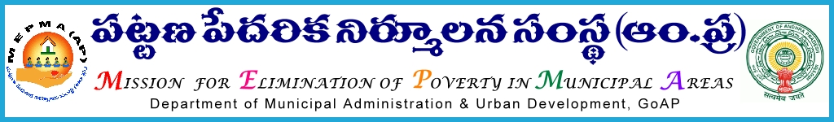 From To
Sri Solomon Arokia Raj ,I.A.S., The Project Directors MEPMA
Mission Director,MEPMA PO,UCD of GVMC and VMC.
Hyderabad. Govt.of ÄP, Hyderabad.

Lr. Roc.No.15183/BL/2015-16, Dated:- 02-11-2015.
Sir,
Sub:- One day Work shop for DMCs - Bank Linkage and DEOs of NULM towns and
DPMU at Guntur on 07-11-2015. Communicated – Regarding.
Ref: - Instruction of the Spl.Director during the Review held at HO on 02-11-2015.
*****
It is decided to hold a One day work shop on 07-11-2015 at 10.00 am, on Data updation of SHG Bank Linkage and other related issues in MEPMA Website, with the DMCs ( BL), DEO of the DPMU and the DEOs of all NULM towns at Guntur.
The Venue for the work shop will be informed later to all the PDs through mail/ SMS, which will be attended and reviewed by the Spl.Director, along with the SMCs BL & IB, and Banking Anchor person of SERP HO and representative from TCS.
All the PDs of therefore requested to depute the above staff for the work shop on 07-11-2015 without fail and pay the eligible TA & DA from IEC funds of NULM. The TA & DA pertaining to the DMCs of GVMC & VMC may be paid by the PDs of Visakhapatnam & Krishna respectively.
The PD Guntur is requested to make the necessary arrangement for the one day work shop from 10.00 am to 5.00 pm (Food & Snacks) and the required logistics.

Sd/- (P. Chinna Thathaiah)
For Mission Director.
AP, MEPMA.

Copy to the Director Bank Partnerships – SERP, AP.
Copy to TCS, Vijay pillay.

