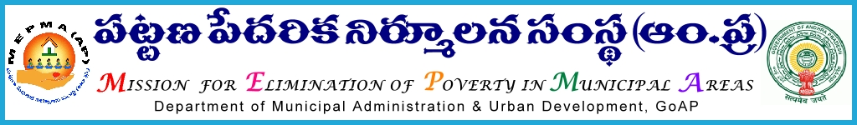

From To
Sri Solomon Arokia Raj,I.A.S., The Project Directors,
Mission Director,MEPMA MEPMA,AP
Hyderabad. The PD GVMC , VMC

Lr Roc. No. 584/LH /MEPMA/ C Dated 2.11.2015

Sub: - MEPMA – Livelihood – Grounding and online updation of Livelihood Units in the all ULBs for the year of 2015-16 – Showing poor progress – completion before November 5th 2015 - certain Instructions – Communicated – Reg.

Ref : - 1. Letter.Roc.No.610/c dated :9/9/20115
2. Letter.Roc.No.584/LH/C dated : 30/9/2015 .

***
It is to inform that instructions have been issued for implementation of livelihood activities ,grounding and online updation of livelihood units in all the ULBs.During the review meeting held on 31/10/2015 at Tirupathi also the Special Director directed all the concerned to attend to the said work on priority. But in spite of repeated instructions, low progress is shown in grounding of livelihood units and online up dation in all the ULBs as per the online reports .

All the Project Directors are therefore requested to focus on this item of work and complete the target before 5th November 2015 . PDs should monitor the said work on daily basis by fixing targets to COs/TMCs/TPrOs and complete the task without fail.

Sd/-

For MISSION DIRECTOR

