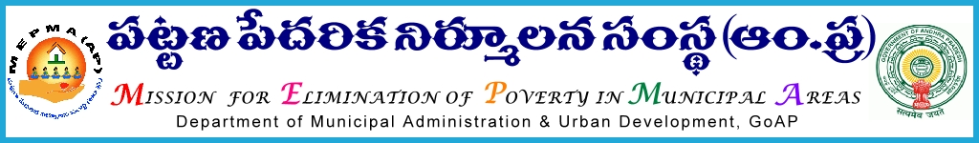

From To
Sri Solomon Arokia Raj, I.A.S., The Project Directors,
Missionl Director,MEPMA All districts .
Hyderabad. Govt.of ÄP, Hyderabad.

Sir,
Lr Roc. No. 2096/ D1- 2015 dated 5.11.2015.

Sub:- NULM– Monthly review meeting with DMCs , IB - certain instructions – issued - regd.
Ref:- 1.PDs conference dated 28th and 29th Aug’2015 & This office circular No 2096/IB dated 14.9.2015.
2. Instructions from SD,MEPMA dated 28.9.2015.
3. Minutes of the review meeting dated 5.10.2015.
4. Teleconferecnes on priority subjects of SM&ID.
5. Instructions of SD MEPMA dated 4.11.2015.

* * *
It is proposed to conduct review with DMCs IB on 9.11.2015 on status of implementation of various activities under Social mobilization & Institution Development at training institute, Gunadala, Vijayawada. The following is the agenda
1..Capital Infusion: Action plan for completion of balance tasks.
- Details of Release of capital infusion to SHGs.
- Released but not credited to SHG a/cs details.
- Details of SHGs not availed Capital Infusion & reasons.
- 0 member groups (details like their functional status, status of availing loan & VLR )
- Status of temporary migration & permanent migration of SHG members.
- Details of Balance no.of SHG members –AADHAR seeding to be done.
- Details of SHGs to which SB Accounts not verified.
- Details of SHG members duplicate in rural & urban .
2.NULM MIS updation on SM&ID.
3.Release of Revolving fund & RO fund to SHGs (2014-15&2015-16).
4.Formation of groups of rag pickers (Entering |MoU with the NGOs by TLFs & present status)
5. Model SLFs ( Online updation
6.Legal compliances of CBOs.
7.PWD SHGs and strengthening.
8. SLF RP strengthening: online data, trainings.
9.Parishkara kendrams,

It is also proposed to work out the policy for ensuring effective functioning of Parishkara Kendrams, established in 32 |NULM towns.

Hence all the PDs are instructed to depute the DMCs IB ,ADMCs (PWDs) & Social action CRPs @ 2 from HQ town from each district & one TLF |President/Secretary from HQ town from each district to the above workshop on 9th Nov’2015 and their TA and other allowances as applicable may be paid from CBT funds of NULM component. PD, Krishna is requested to meet the required expenditure of Rs 20000/- (Rs 8400 /- food for 60 nos + Rs 3100/- training halls + Rs 2000/- room rent for 4 rooms + Rs 2000/- stationery & Miscellaneous + Rs 3000/- resource fee to two resource persons + Rs 1500/- towards travel cost of resource persons ) from CBT component towards training hall charges, food & refreshments, accommodation to the participants and cost of stationery at Gunadala , Vijayawada.

Yours faithfully,
sd/-
for Mission Director, MEPMA

