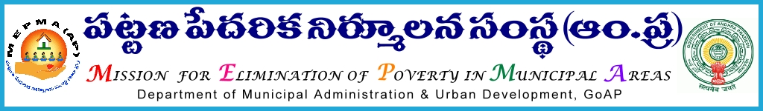

From To
Sri Solomon Arokia Raj, I.A.S., The Project Directors,
Mission Director,MEPMA All districts .
Hyderabad. Govt.of ÄP, Hyderabad.

Sir,
Lr Roc. No. 2096/ D1- 2015 dated 12.11.2015.

Sub:- MEPMA – identification of CRPs - for training on various poverty alleviation programmes - certain instructions – issued - regd.
Ref:- Instructions of MD,MEPMA dated 12.11.2015.
* *
It is proposed to train 1110 CRPs on various poverty alleviation programmes in phased manner . In this context all the PDs are requested to conduct meeting with DMCs IB ,ULB field functionaries and TLF office bearers of ULBs in the district before 13th of Nov’2015 . They may be further instructed to identify new Community Resource persons @ 10 per ULB for giving training programmes on various Poverty alleviation activities and other Govt. Schemes, fulfilling the qualifications mentioned hereunder .
SHG Member with
- Minimum of 3-5 years experience.
- Age group : 35- 45 years .
- Qualification of minimum of 10th passes or fails.
- Better communication skills.
- Passion for social development aspects.
- Willing to attend for residential trainings at other place.
- Preference to be single women or widows.

This may be treated as MOST URGENT and PDs shall send the details in the following proforma through e-mail before 18th of Nov’2015,without fail.

Yours faithfully,
sd/-
for Mission Director, MEPMA

Sl..No. | Name of the ULB | Name of the Member | Name of the Father/ Husband | Age | Educational Qualification | Name of the SHG | Name of the SLF | Languages known (telugu/english/Hindi) | `Experience in SHGs (Yrs.) | Contact Number

