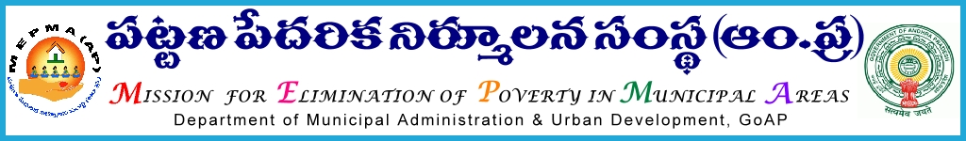

Office of the Mission Director,
MEPMA, A.P, Hyderabad.

Lr Roc. No. 2096/General /2015/NULM dated 26.11.2015

Sub:- MEPMA – Community Feed back on basic amenities – through utilization of CRP services – certain instructions – issued - regd.
Ref:- Instructions issued vide Tele conference by the DMA and Special Director dated 23.11.2015.

* * *
With reference to the instructions of Mission Director, it is to inform that MEPMA has proposed to utilize the services of District Resource Persons and Senior most Community Resource persons in getting community feedback from the wards. In this connection all the PDs are instructed to

- Identify the Master trainers @ 8-16 per each district as per the Annexure enclosed to this letter and send the list along with their contact Nos by 24rd Nov’2015.
- Facilitate ULBs to identify senior most Community Resource Persons (SHG members) @ one covering 4-5 wards or one ward ( as per the annexure enclosed) with minimum qualification of Inter and graduation , age group below 35 years and send the list in following proforma before 25th Nov’2015 to MEPMA office.

Name of the ULB
Name of the Master trainer | Contact No | Name of the CRP | Contact No | Address and ward in which she is residing | Wards allotted | No.of samples to be collected

The following is the action plan:

- Orientation to the Master trainers would be given on 25th through Tele conference.
- Master trainers in turn visit to their ULBs in the district and orient identified CRPs on the process including technical and other aspects on 26th Nov’2015.
- Facilitate to down load the AP relating to the survey and install them in their smart phones.
- In case of non-availability of the smart phones, provision of uploading information online after collecting the data along with photo and geographic location in soft .
- CRPs commence collecting the samples on 27th and 28th and uploading at the same time .

Roles and responsibilities of the Master trainer:
- Orient identified Resource persons on facilitation process and other technical aspects .
- verification of the process followed by the CRPs in the field in collection of sample
- Handholding support to CRPs in the field for 2 days while taking up the sample collection.
- Build confidence by giving support to all CRPs at one sample point and then to disburse them to allotted wards.
- Facilitate them to upload on smart phones practically before going to the field.
Roles and responsibilities of the Community Resource persons:
- Community Resource persons shall collect the samples in allotted wards only ( other than their own ward).
- Has to facilitate community for interaction in informal way only as per the convenient timings of the community i.e., 7.00 -9.30 AM or after 5.30 PM in evenings.
- Samples shall be collected informally on the roads, other informal places only.
- Identify 2-3 sample points well in advance in major wards with more population .
- Has to upload the data on tab then and there itself.
- Avoid political interference.
- Shall avoid involvement of the Government functionaries.
- Shall collect one sample for 2000 population and in Nagara panchayaths one sample per ward . Wherever the population is 3000 - 4000 , she has to collect 2 samples and it is 5000 or above – sample shall be 3 .
- Shall ensure that one sample for each ward is collected.
Roles and responsibilities of the field functionaries:
- Facilitate master trainers to execute task properly.

PDs are instructed to ensure that based on the certification from the master trainers, CRPs would be paid Rs 250/- per day for collecting the samples @ one per 2000 population in allotted 5 wards from TLF RO funds /SM&ID funds and for non-NULM towns it may be met from available funds under other than NULM component . Master trainers may be paid an amount of Rs 750/- per day of training or handholding support in the field and if it Senior CRPs they may be paid Rs 350/- per day of work/handholding support in the field. The above expenditure will be reimbursed from MEPMA after receipt of the funds from C&DMA.

sd/-
for Mission Director, MEPMA

.
Copy to all PDs of MEPMA for n/a

Copy to the Director of Municipal Administration, Hyderabad.

