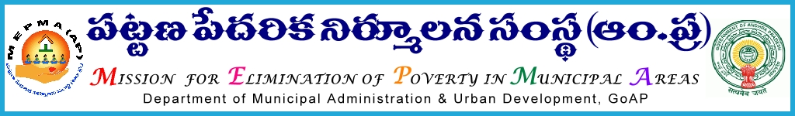

From To
Sri G.Chinna thataiah , The Project Directors,
Special Director,MEPMA MEPMA.
Hyderabad. Govt.of ÄP, Hyderabad.

Sir,
Lr Roc. No. 2096/MEPMA/2015 dated 10.12.2015.

Sub:- MEPMA – strengthening of Community Based Organisations – facilitating SHGs/SLFs/TLFs – for enabling them to change the leadership – as per Bye laws - certain instructions - issued - Regd..
Ref: - 1. Bye laws of SLFs and TLFs and grading indicators for SHGs /SLFs and TLFs and module communicated for SHG strengthening.
2.Review with SLF leaders in different forums by the Principal Secretary /Mission Director/Special Director, etc.

***************
It is to inform that several instructions were communicated to all PDs and concerned DMCs were also requested to facilitate CBOs for change in leadership as per their byelaws for ensuring accountability, transparency in functioning of CBOs which in turn result in their sustainability. During several reviews and the feedback from SLF leaders - it is observed that some of the SHG members are acting as leaders since 5-7 years. In this connection all the PDs are requested to facilitate SHGs/SLFs/TLFs as follows:

The following suggestions are being given basing on the request and feedback of the CBOs at different levels.

- DMCs Institution Building Review the above item with SLF leaders/Resource persons CO wise in regular review meetings and also orient them on change of leadership during TLF meetings and other training programmes given to the CBOs.

- Town Mission Coordinator (TMC) /Town Project Officer (TPrO) would also facilitate SHGs regarding the importance of change of leadership at SHG level during scheduled monthly meetings of SLFs and TLFs in ULBs.

- Utilise the CRPs wherever required to facilitate SHGs for change of leadership and ensure to facilitate that

- SHGs shall be facilitated to change their leader once in 2 years .

- Family members of Government employees shall not be in SHG at any cost and if they are there facilitate them for withdrawal, duly clearing their loans’ and other things by passing resolution. In case of any issues arises for the above task at SHG level , the same may be placed in SLF and resolve the issue.

- SLFs and TLFs would follow the byelaw and ensure that 2/3rd of the leaders would be changed every year during election process, as suggested by the SLF leaders and amend the byelaws if required by passing the resolution .

- Any OB members should not be continued in the same position like President, Vice president, Secretary, Joint Secretary , Treasurer for more than 2 years.

- After completion of the process of changing of OB members, 2/3 for each year or 2 years based on the byelaws. The member who remained to continue can be continued but not in the same position.

- byelaws may be amended accordingly.

Hence all the PDs are instructed to issue necessary instructions to DMC, IB and ensure that change of leadership would be facilitated in all SHGs by 30th of Jan’2015 and data must be kept online from time to time and also send monthly progress report stating the total no.of SHGs and no.of SHGs facilitated for change of leadership . The above subject would be reviewed by the MD, MEPMA during teleconferences’, videoconferences etc.,

(Under the orders of the Mission Director, MEPMA)

Yours faithfully,
sd/- Sri G.Chinna Thataiah,
Special Director, MEPMA.

