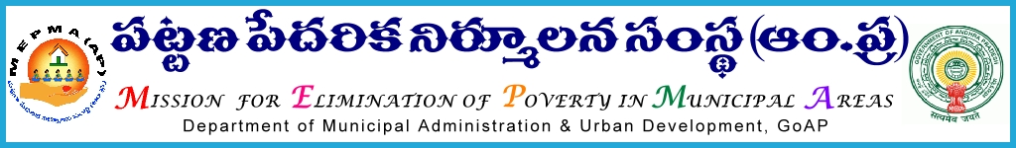

From To
Sri Solomon Arokia Raj,I.A.S., The Project Directors,
Mission Director,MEPMA All Districts
Hyderabad.

Lr Roc.LH/MEPMA/ C1 dated 28.12.2015

Sub:- MEPMA – One day workshop on Maintenance of school Toilets on December 30th
20015 at TTDCs District level– Deputing COs,Sanitation CRPs from AP,MEPMA –
orders– issued Regd.

Ref:- Lr.No.SAC/COO/O&M of Toilets /F.No.31/D.No.57/15,Date:23/12/2015

* * *
It is submitted that, SERP has proposed to conduct one day workshop on school sanitation program to COs//CRPs on 30th December 2015 at TTDCs District level . Resource persons from swatch Andhra corporation will conduct the workshop. These two member teams(CO/sanitation CRP) will be master trainers and will inturn conduct training for all toilet cleaners& school HMs in their Municipalities on a date which will be intimated in 30th workshop.
The details of the participants:

- One CO from each ULB
- One identified sanitation CRP form each ULB

Hence all the Project Directors are instructed to nominate the said members for the said workshop and ensure they would report at the venue by 10.00 AM on the scheduled dates without fail.
Further it is informed that the travel expenditure for Cos/CRPs shall be born from CB&T funds available under NULM as per MEPMA norms, and for non NULM towns the same shall be born from A&OE component

Yours faithfully,
Sd/-
for Mission Director, MEPMA

