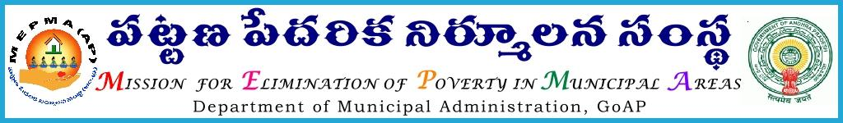

From To
Sri Solomon Arokiaraj, IAS. The Project Directors,
Mission Director, MEPMA AP. State.
Hyderabad.

Sir,
LrRoc.No2096/MEPMA/D1 Dated: 4.03.2016

Sub:- MEPMA- Two days Training Programme on “Gender Responsive Budgeting” From09.03.2016 to10.03.2016-at RCUES, OU, Hyderabad- to the TLF –OB Members –nominating the concerned-Requested- Reg.
Ref:- Letter No 471/RCUES/2015 Date: 1.02.2016.
*************
In the ref. cited, Director, RCUES, Hyderabad, has requested the MD, MEPMA to nominate the field functionaries for training on” Gender Responsive Budgeting “from 9th to 10th’ March, 2016 at RCUES, Hyderabad. Hence it is proposed to nominate the TLF- OB Members from the State of Andhra Pradesh for the above training. PDs of all the districts are instructed to nominate TLF-OB Members @ 03 per each District (Minimum Educational qualification of Inter & age group below40 years) for the above training programme and ensure their attendance at the said venue by 9.30AM on 9th March’2016. Necessary travel allowances to the above participants may be paid from CBT funds available under NULM.

Yours faithfully,
Sd/-
for Mission Director, MEPMA,
Copy to Director, RCUES, Hyderabad.

