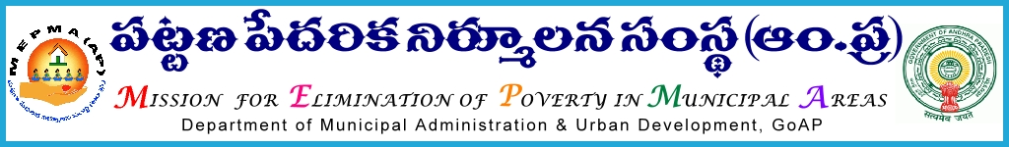
From To
Sri Solomon Arokia Raj, I.A.S., Project Directors,
Mission Director,MEPMA MEPMA.
Hyderabad. Government of A.P, Hyderabad.

Sir,
Lr Roc. No. 2096/IB - 2015 dated 4.3.2016.

Sub:- MEPMA – A.P Open school society – Admission into OBE level ‘A’ (class III) and OBE level ‘C’ (class VIII) 2015-16 – motivating 14+ adults, School drop outs ,working men and women who discontinued studies due to various reasons – certain instructions – issued regarding .
Ref:- 1. This office circular Rc No 2096/IB dated 10.2.2016.
2. D.O Lr No: 4 /OBE/B2/APOSS/2015 dated 10.2.2016.
* *
In the reference 1st cited instructions were already issued to take up Sanga Sandarshini from 20th Feb’2016 to 19th Mar’2016 towards strengthening of SHGs in urban areas with focus on

- Streamlining of the SHG data through data collection and correction
- Verification of livelihood units and rectifying the data.
- Regularization of NPA and OD Accounts of SHGs .
- Renewal of Abhaya Hastham membership.

In this connection,it is stated that in the reference 2nd cited, Secretary to Government, School Education department , has requested this office for extending cooperation in the field for motivating the community for enrolling 14+ adults, School drop outs ,working men and women who discontinued studies due to various reasons for admission into OBE level ‘A’ (class III) and OBE level ‘C’ (class VIII) 2015-16.

Hence, all the PDs are requested to conduct district level meeting with TLF presidents and explain them in brief about the programme in coordination with the line department and request them to extend their cooperation in identifying the men and women i.e., 14+ adults, School drop outs ,working men and women who discontinued studies due to various reasons and ensure their admission into OBE level ‘A’ (class III) and OBE level ‘C’ (class VIII) 2015-16. Necessary support may be taken from the concerned department at the district level .

Yours faithfully,

sd/- for Mission Director, MEPMA.

