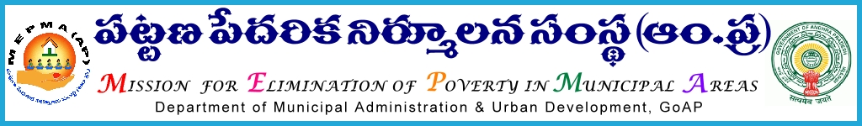

From To
Sri Solomon Arokia Raj ,I.A.S., The Project Directors,
Mission Director,MEPMA MEPMA.
Hyderabad. Govt.of ÄP, Hyderabad.
Sir,
Lr Roc. No. 2096/MEPMA/2015 dated 28.3.2016

Sub:- MEPMA – Action plan 2016-17 – certain instructions - issued - Regd..
Ref: - Instructions issued dated 26.3.2016 by MD, MEPMA & SD, MEPMA .

*************
It is proposed to take up several Poverty Alleviation activities under various componetns of NULM & other activities of MEPMA, coverng all ULBs in the State during 2016-17. In this connection, indicative action plans suggesting the activities to be taken up under componnetns of NULM &MEPMA are enclosed as follows:

- Social mobilisation (IB, CB, gender , Ragpickers, PWDs etc.,)
- Bank linkages,
- Sthreenidhi,
- SHG livelihoods,
- placement linked skill trainings,
- Self employment & group employment,
- Social Security , Health and Nutrition etc.,
- Shelters for Urban Homeless.
- Support to Urban Street vendors.

Hence , all the PDs are instructed
- to communicate the same to ULBs duly incorporating other items as per the requirement at ULB and district level before 31.3.2016.
- To conduct Town level meetings with SLF OB/RP members and CD staff and complete the action plans CO wise at ULB level along with TLF resolution before 5th of April’2016.
- To condut District level meetings with CD staff,DPMU staff & TLF OB members before on 6th and 7th April’2016 and send consolidated district level action plans to MEPMA by 11th Arpil’2016. They may invite District Collectors, representatives of line departments, Bankers for the above meeting exclusively for livelihood component .
PDs conference is proposed to be conducted on 12th and 13th of April’2016 to discuss and finalise action plan . Exact date ,time & venue of the conference will be intimated seperately.
Yours faithfully,
sd/-

for Mission Director, MEPMA.

