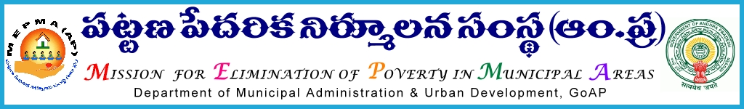

O/o the Mission Director,
Mission for Elimination of Poverty in Municipal Areas,
Andhra Pradesh, Hyderabad.

CIRCULAR

Cir. Roc. No: 271 / C / 2015, Dated: 02-04-2016

Sub: - MEPMA – M & E – Project Directors conference to be held on 10th & 11th May’ 2016 - Communicated – Regarding.
Ref: - This office Cir. Roc. No: 271 / C / 2015, Dated: 29-04-2016
<><><>

Vide reference cited, instructions have been issued on conduct of 2 day State level conference with all the Project Directors of MEPMA on 4th & 5th May’ 2016 at Vijayawada to review the progress of 2015-16 under all the activities of MEPMA and finalization of Annual Action Plan 2016-17 the said conference is postponed and is proposed to be conducted on 10th & 11th May’ 2016 in the Conference hall of Sub Collector’s Office, Vijayawada.

Therefore, all the Project Directors are hereby requested to attend the conference along with DMCs, TMCs and ADMCs together with progress reports and Action Plan 2016-17 upto CO level. The Project Director, Krishna District is directed to make necessary arrangements and logistic support for the above conference. Agenda and programme schedule will be communicated separately.

Sd/-
for MISSION DIRECTOR

To,
All the Project Directors of MEPMA in the State.
Copy submitted to the principal Secretary to Govt. (MA), MA&UD dept. for kind information
Copy submitted to MD, MEPMA for kind information.
Copy submitted to DMA, AP for kind information.
Copy submitted to OSD to Hon’ble Minister for MA&UD for kind information.

