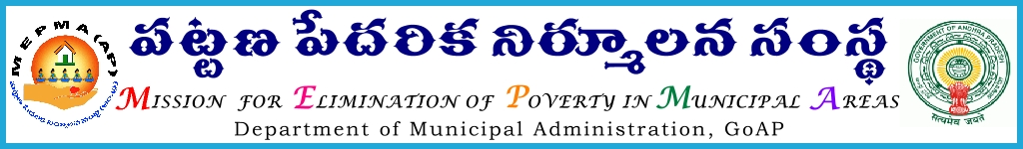
From To
Smt Anita Ramachandran, IAS., All the Project Directors of
Mission Director, DPMUs in the State.
MEPMA, The Municipal Commissioners of .
A.P., Hyderabad. all H.Q Municipalities
The Commissioners of all Corporations

Roc. No. 7605/2010/G ,Date: 23 .12.2014
Sir,
 | Sub:-  Ref:- | MEPMA – Establishment- Video Conference with the Project Directors, DPMUs, Municipal Commissioners of Dist HQ Municipalities and Commissioners of Municipal Corporations on 24.12.2014 from 11.00 AM to 1.00 PM- Requested to participate –Reg.  Govt.Memo.No.18705/UBS/2014,dt:23-12-2014.
 |  | <><><>
In the reference cited, Special Secretary to the Government, MA&UD Deptt proposes to discuss the matter of distribution of pensions in urban areas and requested to attend the video conference proposed by the CEO, SERP from 11.00 AM to 1.00 PM on 24-12-2014.

All the Project Directors, DPMUs are therefore, requested to attend the video conference from 11.00 AM to 1.00 PM on 24-12-2014 along with the Municipal Commissioners of District Head Qtrs Municipalities and Commissioners of all the Corporations with relevant information without fail.
.
Yours faithfully,
R.Sambasiva Rao
Addl. Mission Director (Admn)

Copy to the C&DMA, A.P., for information
Copy to the CEO, SERP, A.P. for information
Copy to the Spl. Secretary to the Government, MA&UD Deptt., A.P., Hyderabad.

