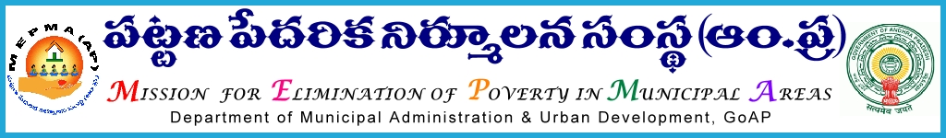

From, To,
Smt Anita Ramchandran, I.A.S., The Project Directors,
Mission Director, MEPMA MEPMA,
Hyderabad Srikakulam,Visakhapatnam, Nellore, Chittoor,
Khammam,Warangal,
Nalgonda, Medak and
Kadapa Districts.

Roc. No 1216/10/D1 dated: 05-01-2013
<<
Sub:- | MEPMA – Release of managerial support to the TLFs – details of resource persons not furnished – Reg
<><><>

I invite the attention of the Project Directors, MEPMA, mentioned in the address entry to the subject cited wherein you have been informed to send the names of Resource Persons of TLFs in your respective districts along with their date of joining to this office for release of managerial support to TLFs. Inspite, reminders you have not submitted the details so far.

Hence, the Project Directors, MEPMA, Srikakulam, Visakhapatnam, Nellore, Chittoor, Khammam, Warangal, Nalgonda, Medak and Kadapa districts are instructed to submit the names of the resource persons and their joining dates duly certified by the concerned Project Director. Then only, managerial support will be released to the TLFs of those districts.

Sd/- Anita Ramchandran
. MISSION DIRECTOR

